Land use gradients drive spatial variation in Lassa fever host communities in Eastern Sierra Leone.

2023-01-25

7,000 words for everything

# Author details.

David Simons. 1,2,3, Rory Gibb 2, Umaru Bangura 4,5, Dianah Sondufu 5, Joyce Lamin 5, James Koninga 6, Momoh * 6, Mike Dawson 5, Joseph Lahai 5, Rashid Ansumana 5, Deborah Watson-Jones 3,7, Richard Kock 1, Kate E. Jones 2.

1 Centre for Emerging, Endemic and Exotic Diseases, The Royal Veterinary College, London, United Kingdom

2 Centre for Biodiversity and Environment Research, University College London, London, United Kingdom

3 Clinical Research Department, London School of Hygiene and Tropical Medicine, London, United Kingdom

4 Bernard-Nocht Institute for Tropical Medicine

5 Njala University, Bo, Sierra Leone

6 Kenema Government Hospital, Kenema, Sierra Leone

7 Mwanza Intervention Trials Unit, National Institute for Medical Research, Mwanza, Tanzania

# Abstract

350 words, simple, factual, numbered statements. Point 1 context and need for work, 2 the approach and methods used, next 2-3 outline the main results. Finally the wider implications and relevance to policy **Policy implications**.

The natal multimammate mouse (*Mastomys natalensis*) is the primary reservoir species of the zoonotic infectious disease, Lassa fever (*Lassa mammarenavirus*). This disease is endemic to Sierra Leone with the highest incidence of human infection reported from the Eastern Province. The spatial occurrence and abundance of this rodent species is regulated by the human environment and biotic interactions within small mammal communities, little is known about these effects even in highly endemic areas of Lassa fever. We conducted a rodent trapping study at four village study sites between 2020-2023, comprising 40,152 trap nights to understand how *M. natalensis* is distributed across a gradient of landuse types and how this may be influenced by the broad small mammal community structure. We conducted a Bayesian multiple species occupancy model, accounting for imperfect detection, to test the hypothesis that *M. natalensis* were more likely to occur within human dominated landuse types. We found that *M. natalensis* occurrence increased from less to more human dominated landscapes. We further found that this effect was not replicated across scales as the probability of occurrence in peri-urban settings was lower than in rural settings. Interactions within the small mammal community appeared to moderate the occurrence of *M. natalensis*, with the presence of *Mus musculus*, but not *Rattus rattus* reducing the probability of occurrence of *M. natalensis*. This finding may explain prior observations of lower-than-expected human cases of Lassa Fever fever from urban settings in endemic regions. Our findings highlight the spatially heterogeneous distribution of rodent species across landuse gradients with implications for the hazard of Lassa fever outbreaks.

# Introduction

Lassa fever, caused by *Lassa mammarenavirus* (LASV) is an endemic zoonotic infectious disease in West Africa. There are large uncertainties around estimates of the annual number human of infections in the region of between 100,000-4,383,600 (McCormick et al. 1987; Basinski et al. 2021). The majority of infections remain undetected and it is estimated that up-to 80% of these are pauci- or asymptomatic infections (McCormick et al. 1987). Few infections are expected to lead to clinically severe cases but outcomes in confirmed clinical cases remains poor, with a reported case fatality rate of 16.5% (Simons 2022). Anthropogenic landuse change and changing climate are proposed to increase the suitable area for both the primary reservoir of LASV (*Mastomys natalensis*) and environmental suitability for the virus itself (i.e. increased temperature and precipitation), together increasing opportunities for viral spillover into growing human populations (Redding et al. 2016, 2021; Klitting et al. 2021). Lassa fever is currently considered endemic in eight West African countries (Nigeria, Guinea, Sierra Leone, Liberia, Mali, Benin, Ghana and Togo) (World Health Organisation 2022). The location, scale and frequency of Lassa fever outbreaks in human communities is highly spatially heterogeneous within these countries. For example, within Sierra Leone, Lassa Fever is typically reported from rural settings in the East of the country. The drivers of spatial clustering of human cases are unknown, in part due to geographical biases in reporting and research effort, but also because the potential drivers of this heterogeneity in Lassa fever risk have rarely been systematically studied (Simons et al. 2023).

The persistence, or lack of persistence, of LASV infection in rodent communities may be one factor driving the observed spatial clustering of zoonosis spillover into human populations. Persistence of the pathogen within *M. natalensis* communities may not occur if these populations are geographically isolated and below a critical density or abundance. Anthropogenic landuse change regulates small mammal communities through local abiotic environments and biotic interactions with other small mammal species.

*Mastomys natalensis* is found in 13 of 14 continental West African nations (the species has not been reported from The Gambia) and in all other sub-Saharan African countries (IUCN 2016). It is a commensal rodent species and is abundant in and around areas of human-dominated landscapes where it is considered a pest species (Leirs, Verhagen, and Verheyen 1993). The introduction of non-native commensal rodent species (i.e., *Rattus rattus* and *Mus musculus*) has led to increased competition for resources and displacement of *M. natalensis* from some locations within its natural range (Cuypers et al. 2017; Garba et al. 2014). Population dynamics within this reservoir species, correlated with resource availability and rainfall pulses (with increased abundance at the beginning of the dry season), are associated with outbreaks of Lassa fever in human populations (Redding et al. 2021). Few studies to date have used longitudinal, high intensity rodent trapping to characterise rodent species communities in Lassa fever endemic regions (Simons et al. 2023). Understanding the spatial distribution of *M. natalensis* and their population dynamics in the context of competing rodent species is vital to guide investigations of the epidemiology of Lassa fever (Basinski et al. 2021).

The occurrence of *M. natalensis* in human dominated habitats has been reported from Guinea, Nigeria and Sierra Leone []. Few studies have investigated their occurrence systematically along landuse gradients of anthropogenic disturbance [].

Here, we conducted repeated, systematic, rodent trapping in the Eastern province of Sierra Leone, along a land-use gradient to model the association of landuse and occurrence of *M. natalensis* and more generally small mammal communities. We aimed to investigate the following questions. First, what is the diversity of rodent communities in varied landuse types in Eastern Sierra Leone? Second, how do patterns of landuse affect the occupancy of *M. natalensis* and other sympatric rodents? Finally, is there evidence that the local spatial distribution of *M. natalensis* is regulated by biotic interactions with co-occurring species? We expect these analyses to further our understanding of rodent community structures that may explain observed patterns of Lassa fever spillover.

# Materials and methods

## Rodent sampling

We conducted rodent trapping surveys between October 2020-February 2023 within and around four village study sites (Baiama; latitude = 7.8375, longitude = -11.2683, Lalehun; latitude = 8.1973, longitude = -11.0803, Lambayama; latitude = 7.8505, longitude = -11.1969, and Seilama; latitude = 8.1224, longitude = -11.1936) in the Lassa fever endemic zone of the Eastern Province of Sierra Leone (Figure 1A.). Surveys were conducted within trapping grids along a landuse gradient of anthropogenic disturbance comprising, forest, agriculture (including fallow and currently in-use areas), and villages (within and outside of permanent structures) (See Supplementary Material 1 for images representative of trapping grid locations). Trapping grids were designated during the initial trapping survey session, one grid was deployed in forest land use, three to four grids were deployed in agricultural land with two grids deployed in village land use. For one village study site, Lambayama, there were no local forest areas, so this landuse type was omitted (Figure 1B-E). Trapping survey sessions within each village occurred four times annually with two trapping surveys in each of the rainy and dry seasons (May to November and December to April, respectively), giving a total of 9 trapping sessions over the study period (Figure 1F).

Village study sites and trapping grids within the village study sites were selected to be representative of land use in the Eastern Province of Sierra Leone and based on accessibility to the sites during all seasons and acceptability of the study protocol to the village study site communities (Supplementary Material 2). Supplementary material 2 contains detailed information about the trapping process. Briefly, at each trapping grid 49 Sherman traps (7.62cm x 8.89cm x 22.86cm) (H.B. Sherman Traps, Tallahasee, USA), were placed in a 7 trap by 7 trap grid, traps were placed 10 metres apart in a regular grid conforming to the local landscape (mean trapping grid area = 2,197m2). For traps placed within permanent structures trap placement varied from this grid structure. Permanent structures were selected semi-randomly at each visit from a grid projected over the village area, with four traps placed within each structure. The location of each individual trap within trapping grids was geolocated for subsequent data processing. Traps were baited with a locally produced mixture of oats, palm oil and dried fish. Each morning the traps were checked and closed for the day prior to re-baiting during the evening. Each trapping survey session consisted of four consecutive trap-nights (TN) at each trapping grid within the village study site.

The location data of individual traps were harmonised to standardised trapping grid cells. First, a convex hull of a trapping grid across all trapping survey sessions was produced. Second, a regular grid was constructed to overlay this area with a grid cell size of 49 m2, individual traps were allocated to these grid cells if they were contained within its borders. This produced 1,939 unique 49 m2 trapping grid cells that individual traps were allocated to for all subsequent analysis (See Supplementary Material 3 for a schematic of this process). The sf package in the R statistical computing language (R version 4.1.2) was used for geospatial manipulation and analysis (Pebesma 2018; R Core Team 2021). The four consecutive trap-nights obtained from each trap during a single survey are pooled as a single replicate for the subsequent statistical analysis.

All rodent handling was performed by trained researchers, rodents were sedated with halothane and euthanised prior to obtaining morphological measurements and samples of blood and tissue following published guidance (Fichet-Calvet 2014). The study protocol was approved by the Clinical Research Ethical Review Board and Animal Welfare Ethical Review Board of the Royal Veterinary College, UK and Njala University, Sierra Leone (URN: 2019 1949-3 and **X**). The rodents’ sex was determined based on external and internal genitalia. Images were obtained of rodents dorsal and ventral aspects. Age estimation was performed through description of the rodents reproductive status (identification of perforate or imperforate vagina, scarring from prior embryo development, current pregnancy status or descent of testes and seminal vesicle development) and weighing of dried eye lenses. Carcasses were destroyed through incineration to eliminate the risk of onward pathogen transmission.

## Species classification

Taxonomic identification was performed in the field based on external characteristics using a taxonomic key, including external morphological measurements and characteristics, developed from Kingdon and Monadjem (Supplementary Material 4) (Kingdon and Happold 2013; Monadjem et al. 2015). Morphological identification alone is unable to distinguish some small-mammal species within the study area at species level. Therefore, molecular identification was performed on whole blood, tissue or dried blood spots. Samples were stored at -20°C until processing, genomic DNA was extracted using QIAGEN DNAeasy kits as per the manufacturers instructions (Supplementary Material 2) (QIAGEN 2023). DNA extracts were amplified using platinum *Taq* polymerase (Invitrogen) and cytochrome B primers (Bangura et al. 2021). DNA amplification was assessed through gel electrophoreisis with successful amplification products undergoing Sanger sequencing. Attribution of obtained sequences to rodent species was through the BLAST programme comparing NCBI species records for rodent cytochrome B to our sample sequences (Supplementary Material 2) (Altschul et al. 1990).

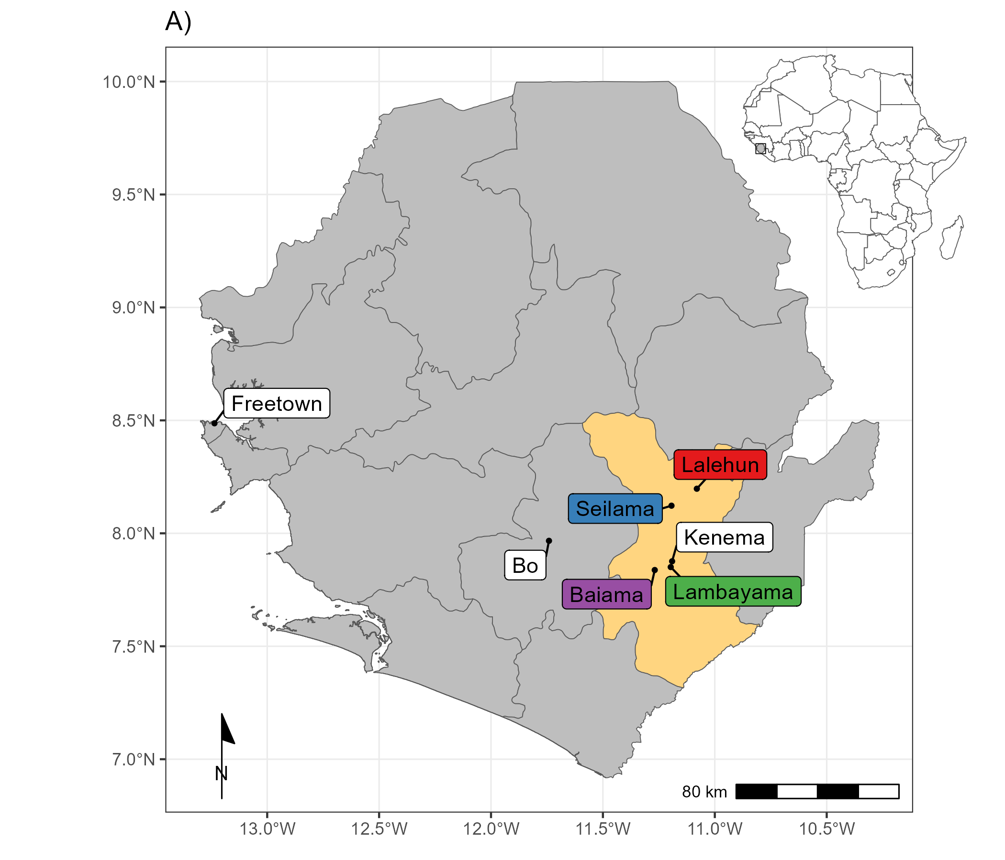

**Figure 1. A)** Location of village study sites (coloured labels), in Eastern Sierra Leone, major cities are shown with white labels. The inset map shows the location of Sierra Leone in West Africa.

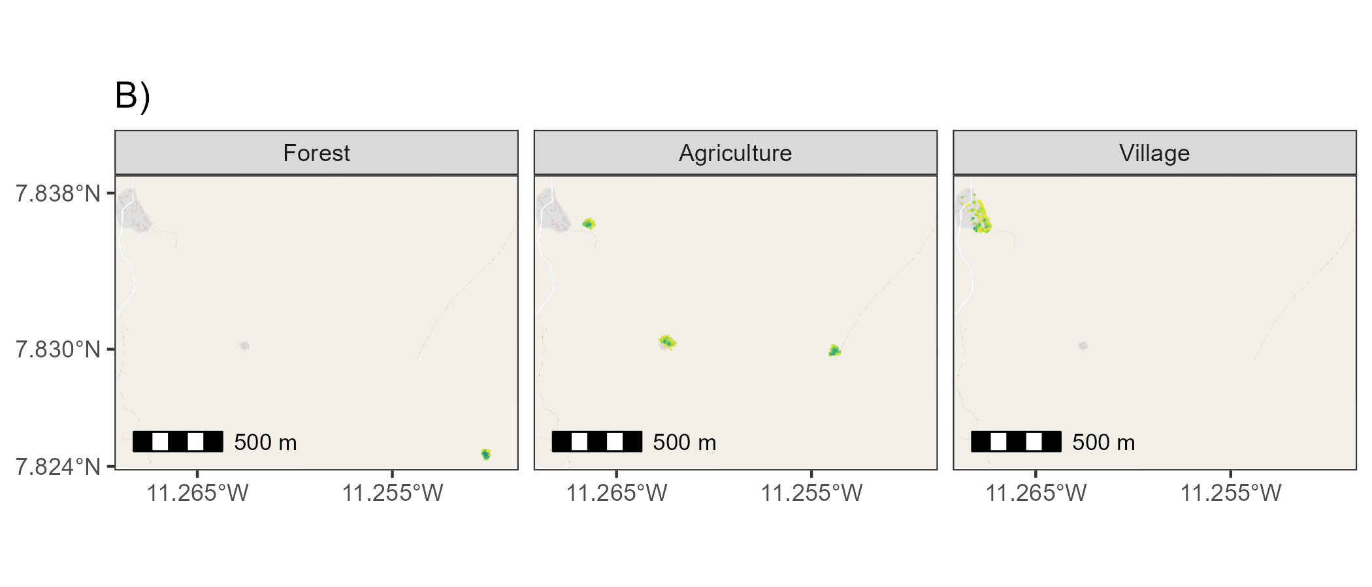

**Figure 1. B)** The location of standardised trapping grid cells in Baiama. Darker colours refer to more trapnights obtained from a 49m2 grid cell. The minimum number of trap nights within a grid cell was 4 trap nights and maximum was 68.

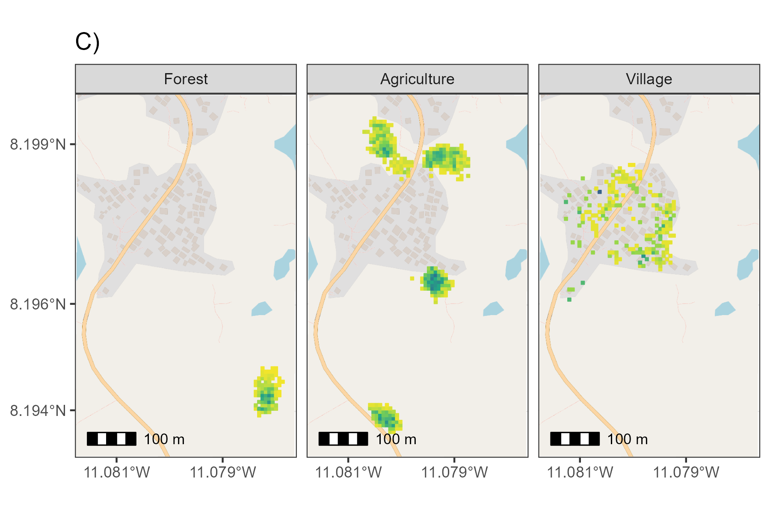

**Figure 1. C)** The location of standardised trapping grid cells in Lalehun. Darker colours refer to more trapnights obtained from a 49m2 grid cell. The minimum number of trap nights within a grid cell was 4 trap nights and maximum was 68.

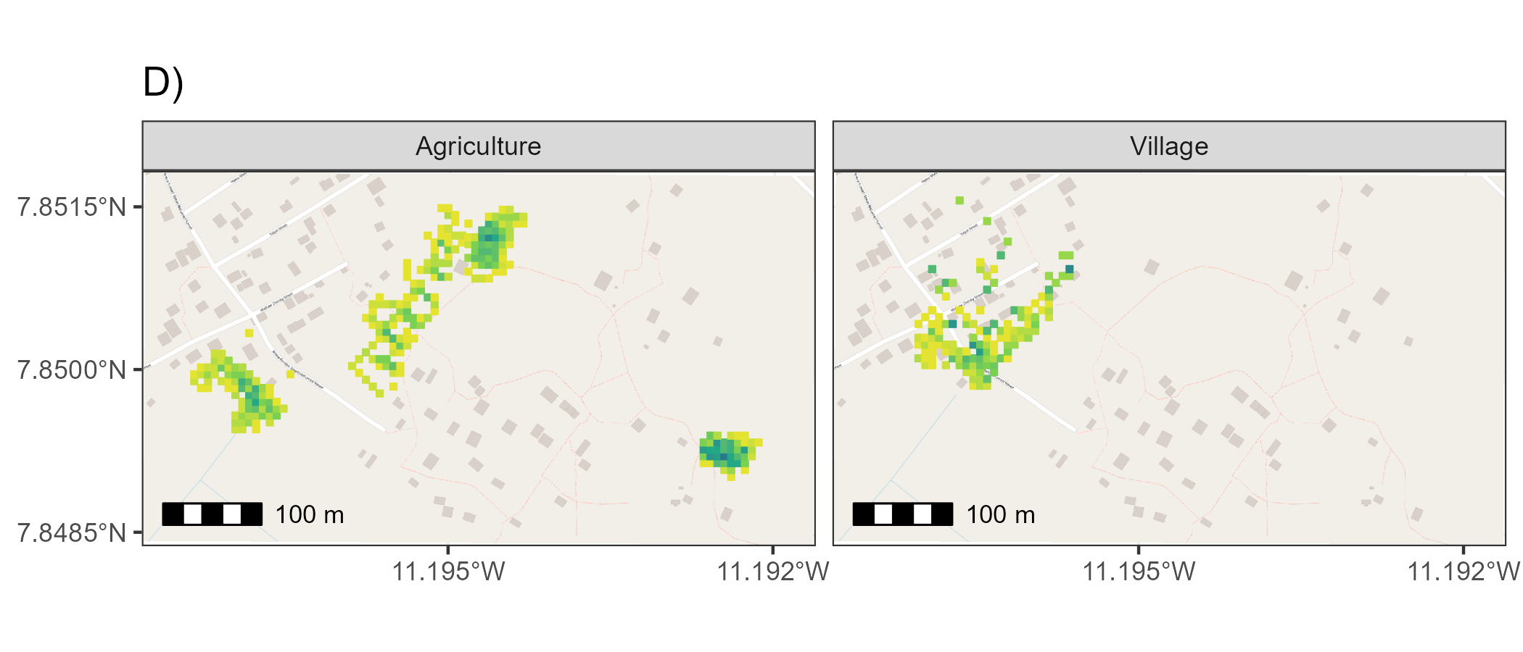

**Figure 1. D)** The location of standardised trapping grid cells in Lambayama. Darker colours refer to more trapnights obtained from a 49m2 grid cell. The minimum number of trap nights within a grid cell was 4 trap nights and maximum was 60.

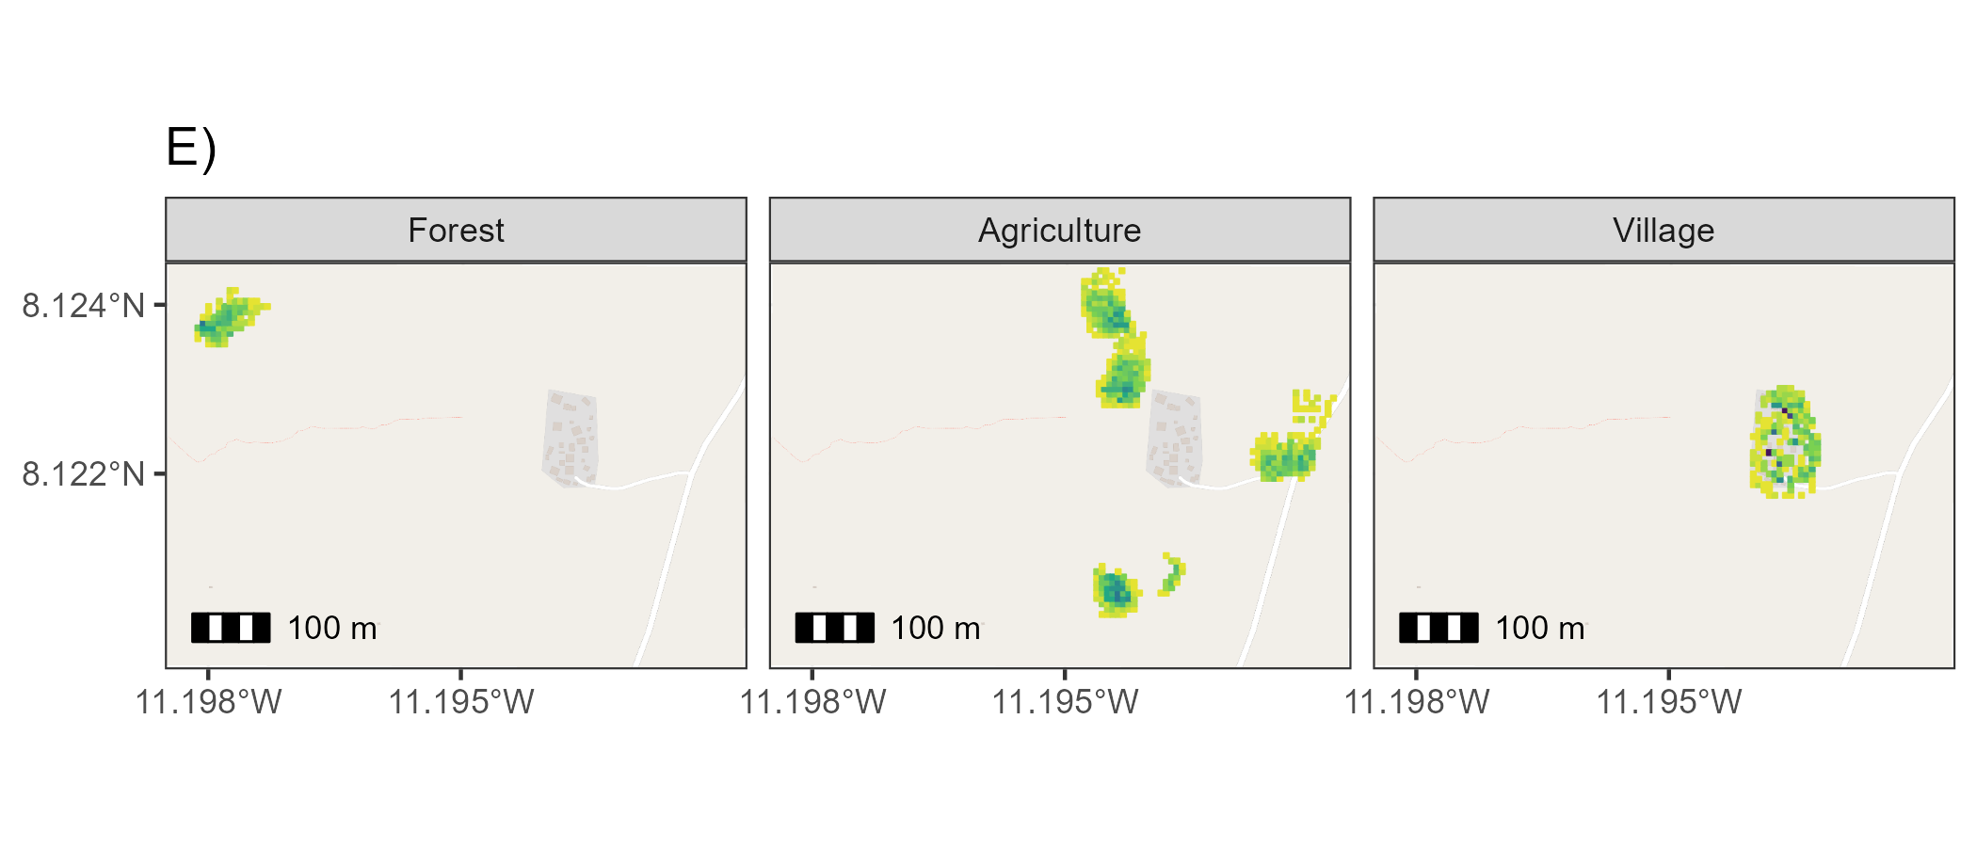

**Figure 1. E)** Location of standardised trapping grid cells in Seilama. Darker colours refer to more trapnights obtained from a 49m2 grid cell. The minimum number of trap nights within a grid cell was 4 trap nights and maximum was 96.

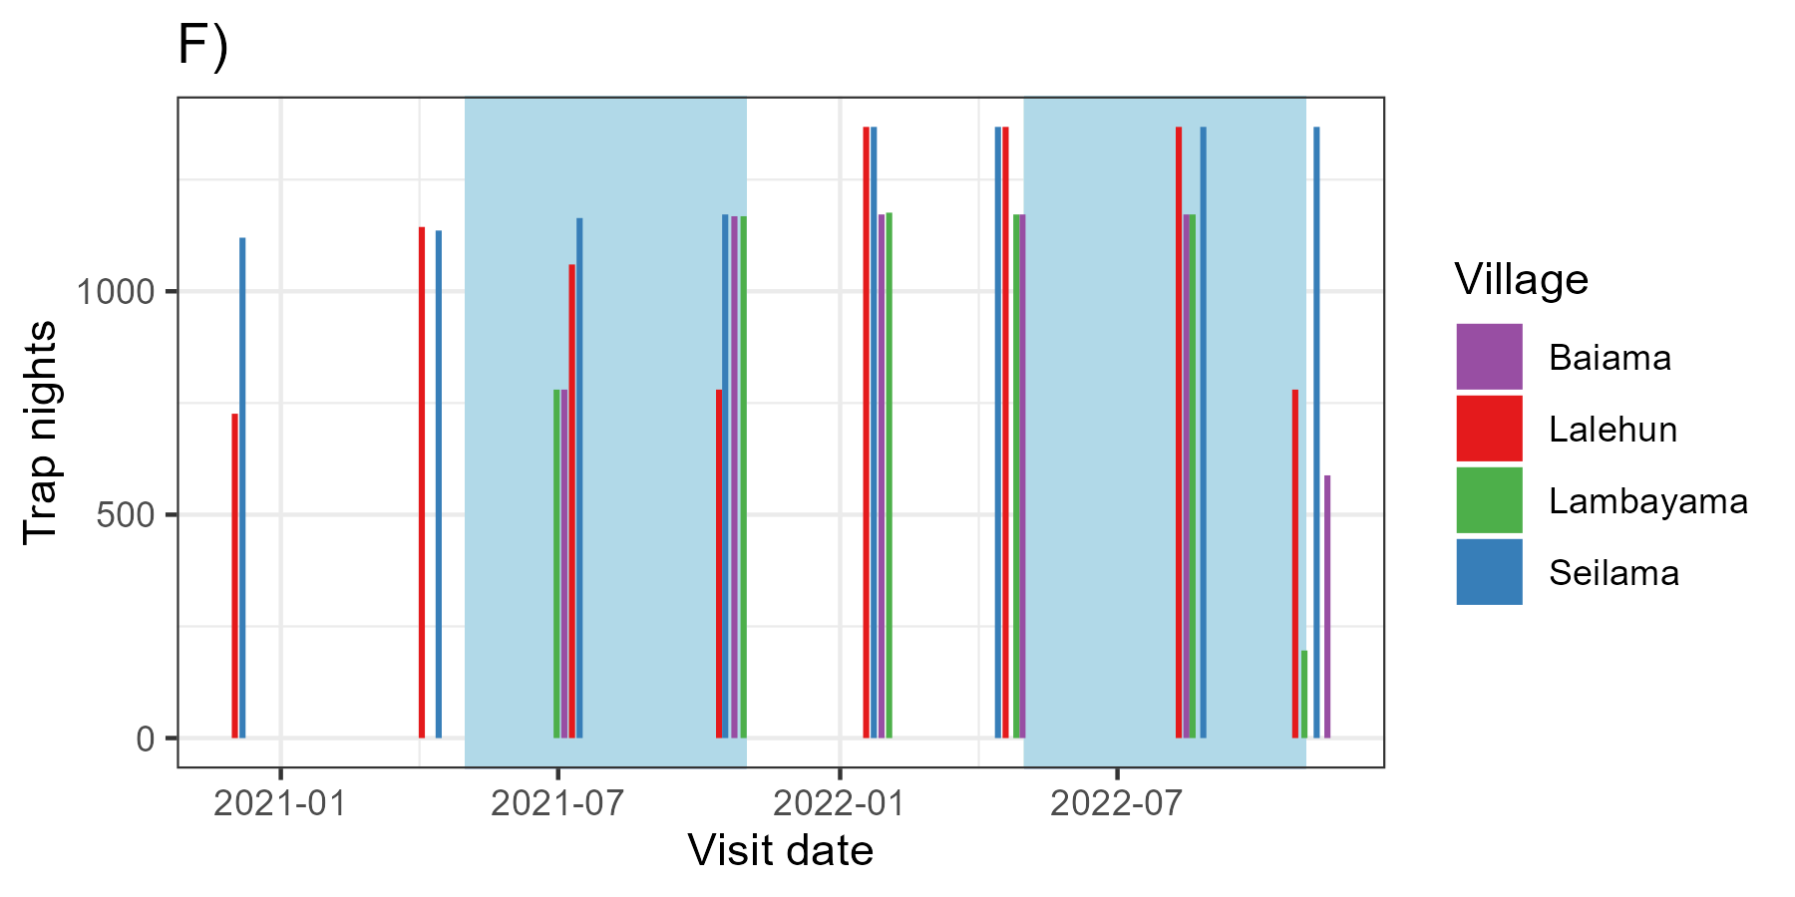

**Figure 1. F)** Number of trap nights obtained from each study village, blue shaded regions represent the rainy season in Sierra Leone. **There is some missing data from sessions, 3, 4 and 8 which will be obtained when I go to SL in February**

## Description of rodent detection and species community structure

Adequacy of sampling effort was assessed using species accumulation curves produced for each village study site and each land use type within a village study site (Supplementary Material 5), suggesting sufficient effort to detect the expected rodent species within these categories. We constructed detection/non-detection histories for each grid cell and rodent species, assigning “1” when the species was detected and “0” otherwise. We describe species communities at multiple spatial scales. First, all species identified across all village sites and land use types. Second, all species identified within a village study site. Third, all species identified within a single land use type within a single village study site. We report species richness and Shannon diversity at these different spatial scales.

## Estimating the effect of land use on species occurrence and richness

To adjust for differential probabilities of detection that may be driven by environmental conditions and trapping effort during the trapping study and between species, we use a Bayesian spatial latent factor multi-species occupancy model that incorporates residual species correlations, imperfect detection and spatial autocorrelation. Variable selection was informed by a pre-specified conceptual model (Supplementary Material 6). Models were defined using the sfMsPGOcc function in the spOccupancy package in the R statistical computing language (Doser et al. 2022). This approach defines the true presence or absence ($​_{z}$) of a species ($​_{i}$), at grid cell ($​_{j}$) as arising from a Bernoulli process (Equation 1.). Where $ψ_{j}$ is the probability of occurrence of a species at a grid cell. This is modelled using a logit link where $β_{i}$ are the species-specific regression coefficients of the site-specific covariates ($x_{j}^{⊤}$) and a latent process ${\text{w}}_{i,j}^{*}$. This latent process incorporates residual species correlations through a small number of latent spatial factors and latent variables representing unmeasured grid cell covariates (Equation 2.). Latent spatial factors account for spatial autocorrelation using a Nearest Neighbour Gaussian Process.

$$z_{i,j}∼Bernoulli\left(ψ_{i,j}\right)$$

$$logit\left(ψ_{i,j}\right)=x_{j}^{⊤}β_{i}+{\text{w}}_{i,j}^{*}$$

The species-specific regression coefficients ($β_{i}$) are specified as random effects arising from a common community level distribution (Equation 3.). Where $μ_{β}$ represents the community level mean effect for each occurrence covariate effect and $T_{β}$ is a diagonal matrix representing the variability of these among the species in the community.

$$β_{i}∼\text{Normal}\left(μ_{β},T_{β}\right)$$

The detection component estimates the unobserved $z_{i,j}$. Here, $y_{i,j,k}$ is the observed detection or non-detection of a species $i$, at site $j$, during replicate $k$ (Equation 4.). This is approached as arising from a Bernoulli process conditional on the true latent occurrence process $p_{i,j,k}$. The probability of a species being detected at a grid cell, during a replicate (given it is present at grid cell $j$), is a function of grid cell and replicate specific covariates $v$ and a set of species-specific regression coefficients $α_{i}$ (Equation 5.).

$$y_{i,j,k}∼Bernoulli\left(p_{i,j,k}z_{i,j}\right)$$

$$logit\left(p_{i,j,k}\right)=v_{i,j,k}^{⊤}α_{i}$$

Similarly to Equation 3., these coefficients are specified as random effects arising from a common community level distribution, where $μ_{α}$ represents the community level mean effect for each detection covariate effect and $T_{α}$ is a diagonal matrix representing the variability of these among species in the community (Equation 6.).

$$α_{i}∼\text{Normal}\left(μ_{α},T_{α}\right)$$

Minimally informative priors were specified for community and species level coefficients ( $α$ and $β$, a normal prior of mean = 0, variance = 2.72) and for community level occurrence and detection variance parameters ( $T_{α}$ and $T_{β}$, 0.1 for the scale and shape parameters of the inverse Gamma prior).

We included covariates in the model based on a pre-specified conceptual model and after assessing for co-linearity (defined as strong correlation >0.8) among variables. Continuous variables were standardised by scaling values between 0-1. The fully specified model is defined in Equation 7 and 8 and using a single latent spatial factor.

$$\text{Probability of occurrence}∼\text{Land use type}+\text{Village}+\text{scale}\left(\text{Distance to permanent structure}\right)+\text{scale}\left(\text{Elevation}\right)$$

$$\text{Probability of detection}∼\text{scale}\left(\text{Monthly precipitation}\right)+\text{Moon fraction}+\text{scale}\left(\text{Number of trap nights}\right)$$

Model checks, including mixing patterns of the MCMC sampler and posterior predictive checks were performed as an assessment of goodness of fit. Bayesian p-values were produced at the community level and species level with values greater than 0.1 and less than 0.9 suggestive of adequate model fit. The Widely Applicable Information Criterion was used to guide final model selection (Watanabe 2010). Using this model, we estimate occupancy probability for each species in different land use types. Only estimates for species with detections from at least **10** grid cells are included to avoid inference from limited data.

## Co-occurrence of *Mastomys natalensis* with sympatric species

To investigate the presence of competitive exclusion of the primary reservoir of Lassa fever by other rodent species within these communities we examined the correlation of the probability of occupancy of species pairs. The predicted probability of occupancy at each of the grid cells from our spatial multi-species occupancy model was obtained. We stratified these by landuse type and calculated the Spearman rank correlation coefficient ($ρ$), conducting a two-sided test for statistical significance with a null hypothesis of no correlation between the probability of occupancy for these species. We constrain this analysis to species pairs that were detected in the landuse setting in the observed data informing our model to limit inference from sparse data. Further, due to multiple statistical tests we use a conservative value of statistical significance where *p* <= 0.005 represents a statistically significant association to minimise the reporting of false positive associations (Benjamin et al. 2018). A statistically significant positive correlation was interpreted as species one being more likely to occur in a grid cell of the specific landuse type if species two were present. A statistically significant negative correlation was interpreted as species one being less likely to occur in a grid cell of the specific landuse type if species two were present. The causal mechanism and direction behind any observed correlations can not be inferred from our current analysis.

# Results

## Rodent detection and species community structure

During the study period **530** individuals were detected from **30,364** trap-nights across the four village study sites (**1.7%** trap-success (TS)). The greatest number of individuals, highest species richness and Shannon diversity values were obtained in the agricultural landuse type, meanwhile, TS was greatest within village landuse settings (i.e., within and outside of permanent structures) (Table 1). The village study site of Seilama had the highest overall TS, species’ richness and Shannon diversity and unlike the three other village study sites had the greatest TS in agricultural landuse. Species richness in Seilama was twice that of the peri-urban village study site (Lambayama) with relatively high Shannon diversity across all landuse types. The sole peri-urban village study site (Lambayama) located within the expanding boundaries of Kenema city, had the lowest species’ richness and Shannon diversity with the majority of rodents detected within the village landuse type.

Table 1. The number of individual small mammals (N), the number of trap nights (TN), trap-success (TS %), species richness and Shannon diversity by village and landuse type.

| Village | Landuse | N | TN (TS %) | Species richness | Shannon diversity |
| --- | --- | --- | --- | --- | --- |
| All villages |  |  |  |  |  |
|  | Village | 191 | 7824 (2.4%) | 7 | 1.52 |
|  | Agriculture | 300 | 18968 (1.6%) | 13 | 1.88 |
|  | Forest | 39 | 3586 (1.1%) | 8 | 1.63 |
| Baiama |  |  |  |  |  |
|  | Village | 53 | 1552 (3.4%) | 5 | 0.86 |
|  | Agriculture | 34 | 3324 (1%) | 8 | 1.74 |
|  | Forest | 1 | 1176 (0.1%) | 1 | 0.00 |
|  | Combined | 88 | 6052 (1.5%) | 9 | 1.52 |
| Lalehun |  |  |  |  |  |
|  | Village | 41 | 2060 (2%) | 6 | 1.36 |
|  | Agriculture | 81 | 5456 (1.5%) | 9 | 1.69 |
|  | Forest | 5 | 1078 (0.5%) | 2 | 0.67 |
|  | Combined | 127 | 8594 (1.5%) | 9 | 1.78 |
| Lambayama |  |  |  |  |  |
|  | Village | 64 | 1744 (3.7%) | 4 | 0.50 |
|  | Agriculture | 26 | 3920 (0.7%) | 5 | 0.95 |
|  | Combined | 90 | 5664 (1.6%) | 6 | 1.05 |
| Seilama |  |  |  |  |  |
|  | Village | 33 | 2468 (1.3%) | 6 | 1.42 |
|  | Agriculture | 159 | 6268 (2.5%) | 10 | 1.81 |
|  | Forest | 33 | 1332 (2.5%) | 7 | 1.48 |
|  | Combined | 225 | 10068 (2.2%) | 12 | 1.93 |

The most commonly detected rodent species across all village study sites and land use types was *M. natalensis* (N = **99**, **18.7%**), followed by *Praomys spp.* (N = **81**, **15.2%**), *R. rattus* (N = **71**, **13.3%**), *M. musculus* (N = **57**, **10.7%**) and *Lophuromys sikapusi* (N = **47**, **8.8%**). *Mastomys natalensis* and *R. rattus* were detected at all village study sites, although *M. natalensis* was not detected in forest landuse types (Figure 2.). Conversely, *Hybomys planifrons* and *Gerbilliscus kempii* were only detected in a single village study site, with *H. planifrons* detected in forest landuse and *G. kempii* in agricultural landuse types. The invasive rodent species *M. musculus* was only detected in the Lambayama and Seilama village study sites within village landuse types. The detection rate (the number of individuals detected per 1000 TN) varied by species, landuse type and village study site. The greatest rate of detection was for *M. musculus* in the Lambayama village study site, with the other commensal species *M. natalensis* and *R. rattus* having high detection rates across multiple village study sites within village landuse types. *Praomys spp.* had the highest detection rates in forest and agricultural landuse types.

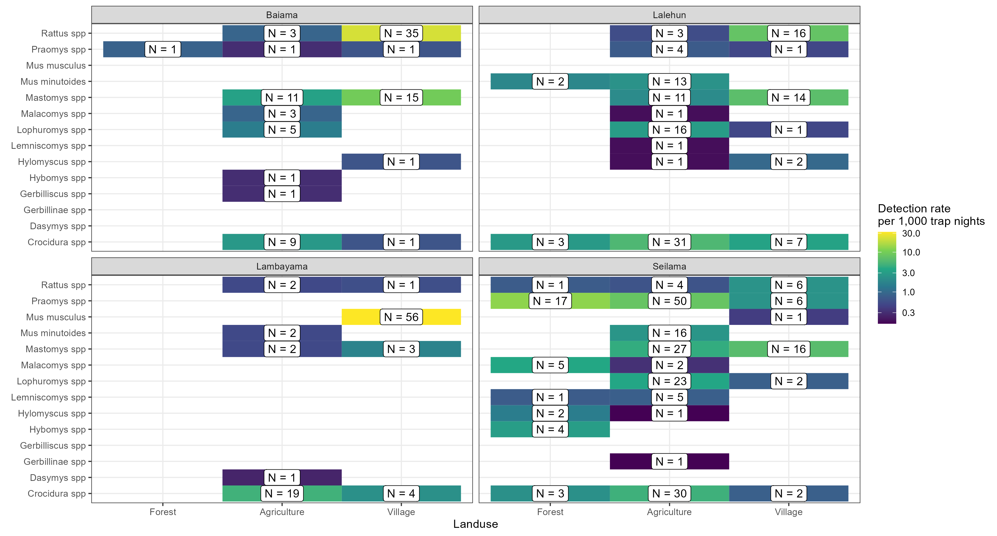

**Figure 2.** Detection rate of rodent species in land use type. The detection rate per 1000 TN and the number of detections of each rodent species in the three land use types across all four village study sites are shown. Landuse category is shown on the x-axis, with species name on the y-axis. The plots are panelled by village study site. The three rural village study sites are Baiama, Lalehun and Seilama, the single peri-urban village study site is Lambayama. The absolute number of detections of each species in each landuse type in each village is shown in the label. The colour of the tile corresponds to the detection rate per 1,000 trap nights. *Mastomys natalensis* was detected at relatively high rates in the village landuse type from all study villages, although at a lower rate in Lambayama where *M. musculus* was detected at the highest rate. *Rattus rattus* was detected in the village and agricultural landuse type at all study villages, although at a greater rate in the village landuse type. Rodent species that were not detected in village land use types were generally less frequently detected throughout the study (i.e., *Lemniscomys spp.*, *Malacomys spp.* and *M. minutoides*)

There was some observed variation in species richness by season. Although, the prevalence of a species (measured as the rate of detections per 1000 TN), not accounting for incomplete detection, did not show a single trend for all species (Supplementary Material 7.). *Mus musculus* had a greater detection rate in the rainy season than dry. Conversely, *L. sikapusi*, *Malacomys edwardsi*, *Gerbillinae spp* and *Gerbilliscus spp* had greater detection rates in the dry season. The other species had similar detection rates across both seasons. There was some further variation when stratified by landuse type. *Mastomys natalensis* had greater detection rates in village landuse types compared to agricultural landuse in the rainy season while in the dry season it was detected at similar rates in village and agricultural landuse. *Praomys spp* had greater detection rates in the forest landuse type during the dry season compared with the rainy season. No other species had important variations by season stratified by landuse type.

## Estimating the effect of land use on species occurrence and richness

We drew posterior samples from the most parsimonious Bayesian occupancy model incorporating spatial autocorrelation to estimate the probability of occurrence of a species within a trapping grid cell (see Supplementary Material 8. for model selection). Occurrence terms included landuse type, village study site and scaled terms for distance to the nearest permanent structure and elevation. Detection terms included scaled precipitation and trapping effort (TN) and the fraction of a full moon. We found three patterns of probability of occurrence ($ψ$) within a trapping grid cell for the seven included species (Figure 3.), marginal effects of the remaining parameters are shown in Supplementary Material 9. First, *M. natalensis*, *R. rattus* and *M. musculus* had greatest probabilities of occurrence in village landuse types with lower occurrence probabilities in agricultural and forest landuse types. *Mastomys natalensis* differed from the two commensal, invasive species (*R rattus* and *M musculus*) as their probability of occurrence in agricultural settings was generally high. Second, *Praomys spp.* had high probability of occurrence in forest landuse types with lower probabilities in agricultural and village landuse types. Finally, *Crocidura spp*, *Lophuromys spp* and *Mus minutoides* had their highest probabilities of occurrence in agricultural land use with lower probabilities of occurrence in forest and village landuse. No species showed high probability of occurrence across all land use types, consistent with species being adapted to distinct ecological niches.

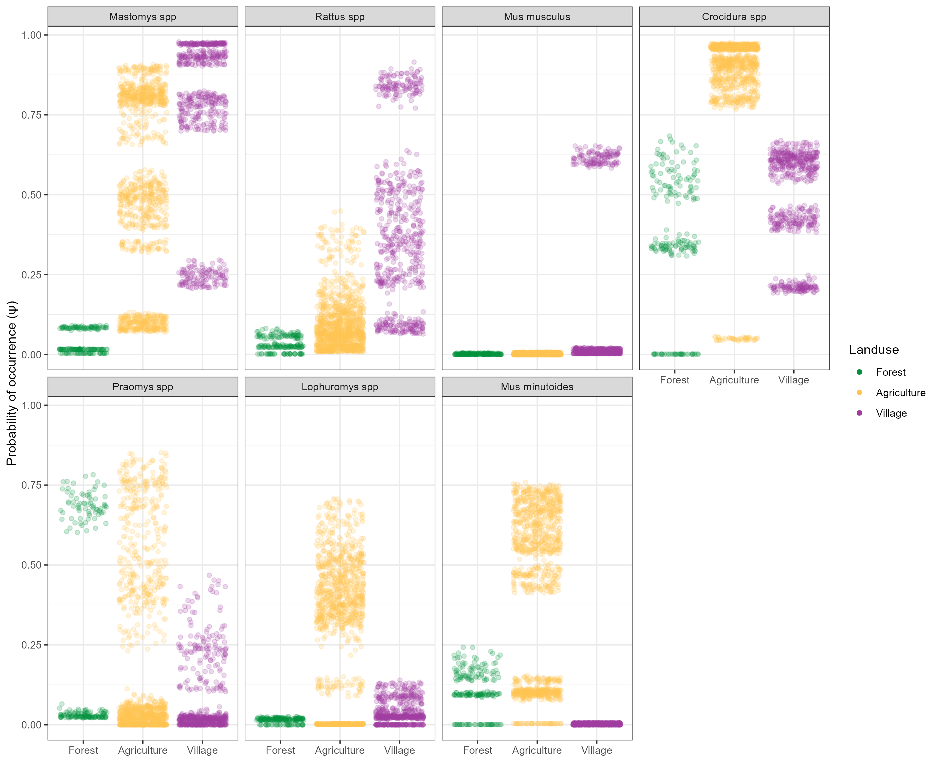

**Figure 3.** Probability of species occurrence across a landuse gradient. The probability of occurrence ($ψ$), within different landuse types, for the seven small mammal species with more than 10 detections is shown. Each point is the median of the predicted probability of occurrence for a species obtained from the posterior distribution at a trapping grid cell. Predictions were obtained for each of the 1,939 trapping grid cells. The y-axis corresponds to the probability of occurrence ($ψ$) at that trapping grid cell stratified by landuse type (x-axis and point colour) for each species. The range of points indicates confidence of the modelled estimate for that landuse type. For example the narrow range of probabilities for *Mastomys natalensis* in forest landuse types (0-13%) is suggestive that the probability of this species occurring within forest settings to be very low. The wide range of probabilities for some species, such as, *Praomys spp.* in agricultural landuse types, between 0-90% is suggestive that in some agricultural grid cells the probability of occurrence was very low while in others it was very likely to occur.

The probability of occurrence within a trapping grid cell of some species within the same landuse types showed wide variability for some species. To further explore this we stratified village study sites by human population density into rural and peri-urban (rural <= 500 individuals per 1km2). The probability of occurrence of *M natalensis* was importantly different, with high probability of occurrence in both agricultural and village landuse settings in rural areas but substantially lower probability in peri-urban village study sites. The same pattern was observed for *R. rattus*. For the rodent species predicted to have lower probability of occurrence in village landuse settings, namely, *Praomys spp*, *Lophuromys sikapusi* and *M. minutoides* probabilities of occurrence were greater in all landuse types in rural areas compared to peri-urban areas. Shrew species were predicted to have similar probabilities of occurrence in rural and peri-urban areas. In contrast, *M. musculus* was predicted to have a low probability of occurrence in all landuse types in rural areas, with high values only for village landuse settings in peri-urban areas. The occurrence probabilities for the three commensal species (*M. natalensis*, *R. rattus* and *M. musculus*) suggest that competition may be reducing the occurrence of *M. natalensis* and *R. rattus* in the presence of *M. musculus* as in it’s absence these two species have high occurrence probabilities in village landuse types.

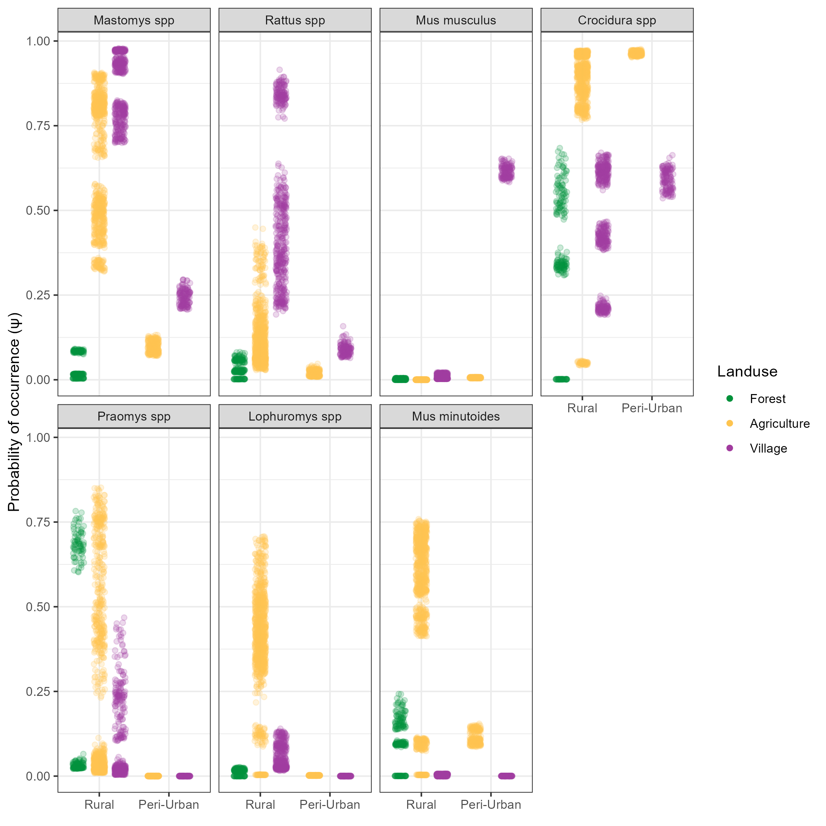

**Figure 4.** Probability of species occurrence across a land use gradient stratified by rural and peri-urban village study sites. The probability of occurrence ($ψ$), within different land use types, for the seven small mammal species with more than 10 detections is shown. Each point is the median of the predicted probability of occurrence for a species obtained from the posterior distribution at a trapping grid cell. Predictions were obtained for each of the 1,939 trapping grid cells. The y-axis corresponds to the probability of occurrence ($ψ$) at that trapping grid cell stratified by both landuse type and whether the trapping grid cell was located in a rural or peri-urban setting (x-axis and point colour) for each species. *Mastomys natalensis* shows an important difference in the predicted probability of occurrence in village and agricultural landuse types between rural and peri-urban settings, with a greater than 50% decrease between rural and peri-urban settings. *Mus musculus* shows an inverse pattern where the predicted probability of occupancy is importantly increased in peri-urban settings and remains very low in rural settings.

## Co-occurrence of species

We hypothesised that the local spatial distribution of *M. natalensis* is regulated by biotic interactions with co-occurring species. Our tests for species correlations supported this for *M. natalensis* and other species’ of the rodent communities (Figure 5.). We observed that in landuse types where both *M. natalensis* and *M. musculus* co-occurred the presence of one species led to a reduction in the probability of occurrence at a grid cell level of the other with a statistically significant very weak negative correlation observed (Spearman’s $ρ$ = -0.15, *p* < 0.001). This negative relationship was not observed between *M. natalensis* and the other commensal, invasive rodent *R. rattus*, where a strong positive correlation between probabilities of occurrences in both agricultural ( $ρ$ = 0.86, *p* < 0.001) and village ( $ρ$ = 0.84, *p* < 0.001) landuse settings was observed. Generally, within village landuse types, high probabilities for the presence of *M. musculus* was associated with lower probabilities for all other rodent species. This was not replicated for *M. natalensis* and *R. rattus*, which did not have a similar effect on the presence of the native rodent species *Praomys spp* and *L. sikapusi*. Within agricultural landuse types the probability for co-occurrence between rodent species were high. Generally, across all landuse types, the presence of shrew species’ had a negative correlation with the presence of rodent species’.

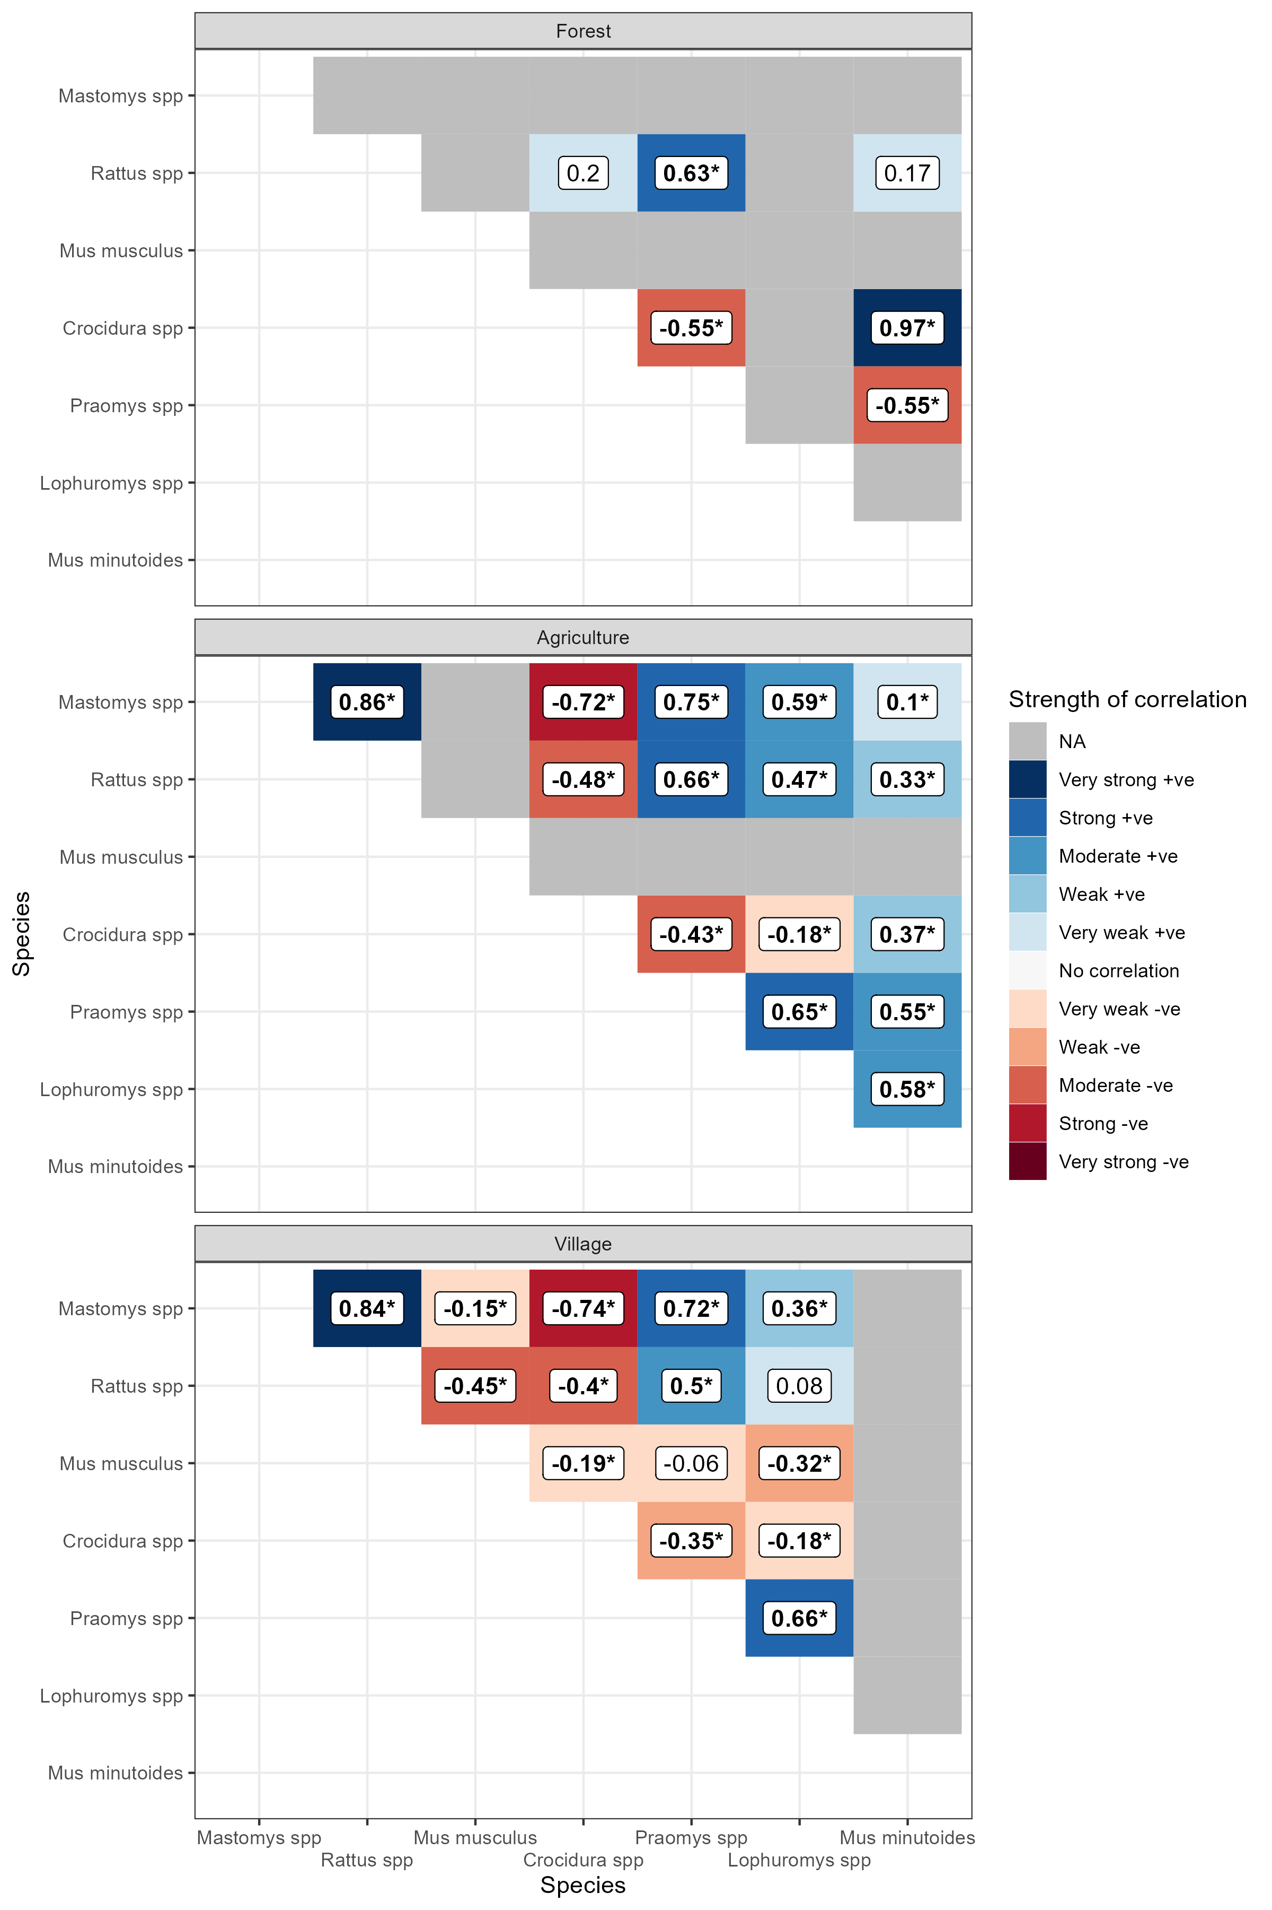

**Figure 5.** Spearman’s rank correlations for the modelled probability of occurrence of species pairs in different landuse types. Positive values (blue shades) represent positive correlation coefficients where an increase in the probability of Species 1 or 2 is associated with an increased probability of Species 1 or 2. Negative values (red shades) represent negative correlation coefficients where an increase in the probability of Species 1 or 2 is associated with a decrease in the probability of Species 1 or 2. Numbers in bold typeface and indicated with an asterisk (*) are statistically significant at a level of* p* <= 0.005. Grey tiles are used where no detections of the species pair in the landuse type were observed in the underlying data informing the model and so were not considered for this analysis to limit inference from limited data.

# Discussion

Here, we have presented findings from a systematic small-mammal trapping study in Eastern Sierra Leone designed to characterise rodent species communities across a landuse gradient in a Lassa fever endemic region. First, we found that species richnness and diversity is greater than that reported from other regions of the Lassa fever endemic zone and that there is a strong association of land-use on the species composition of these rodent communities. Species richness and diversity was generally highest in agricultural landuse settings with lower levels in both forest and village landuse types. There was a high degree of variability in these metrics between our study sites with low species richness and diversity observed in the peri-urban setting compared to the rural setting. Second, the probability of occurrance of the primary host of Lassa fever, *M. natalensis* showed a response to anthropogenic change with highest probability of occupancy in village settings, followed by agricultural settings and likely absence from forest landuse types. We observed similar patterns for the two invasive commensal rodent species *M. musculus* and *R. rattus*. Importantly these patterns could be further identified by stratification on human population density, we found that the probability of occurrence of *M. natalensis* was lower in peri-urban settings where *M. musculus* was the dominant commensal rodent species. Finally, we investigated this further by assessing for correlations in the probability of occupancy. We found a negative association between the probability of occupancy of *M. natalensis* and *M. musculus* within village landuse types that could have important implications for the understanding of risk of spillover of Lassa fever in endemic regions.

## Rodent community diversity is associated with landuse type

## Evidence for biotic interactions shaping patterns of rodent species diversity

## Implications for understanding the risk of Lassa fever spillover

Trap success rate, while comparable to other studies was low. This may have been due to the higher number of trap-nights in this study obtained from non-village settings 22,656 trap-nights (74%), compared to other studies within the region that have placed a higher proportion of traps within household [ref umaru, elisabeth and happi]. Within buildings a trap-success rate of 4.6% is comparable to 3% obtained from a study in Bo, Sierra Leone [ref umaru].

We did not observe that *M. natalensis* was more prevalent in village settings during the dry season, as has been reported from elsewhere in Sierra Leone [ref. umaru], and more generally in the region [ref. elisabeth]. Our finding of similar or increased prevalence of *M. natalensis* was consistent across our village study sites, it may be that in this region different agricultural practices or food storage behaviour by communities may result in different rodent behaviour to elsewhere in its range. Further ecological studies to confirm this observation could be beneficial as prevalence of *M. natalensis* within households is likely to modify the hazard of Lassa fever infection in humans and may limit the generalisability of *M. natalensis* studies from across their range.

Rodent trapping studies typically do not account for variable detection of rodents when reporting observations of individuals references. With trap success rate generally used to account for trapping effort. The probability of a rodent entering a trap and being detected will be influenced by several factors beyond trapping effort that may be time varying and have different impact between species. For example, local activity of rodents may vary by season or light levels. Previous studies have suggested that birth pulses associated with rainfall may increase species abundance which will alter the number of individuals available for detection through increased density of individuals [ref]. Other research has shown that small mammal activity varies by nocturnal light levels, with decreased activity during periods of relatively high luminance (i.e. full moons), resulting from predation pressure [ref]. Here, we have attempted to account for this expected variability in detection probability by including a probability of detection component to our occupancy models. This component including values for trapping effort (number of trap nights), seasonal effects (precipitation), and luminance (moon fraction) within each trapping session.

We found that at the community level there was a positive association between the number of trap nights conducted and the probability of detection of an individual, supporting the approach of high intensity sampling of habitats to accurately characterise species communities. Trapping effort remained an important component of detection across all species with a small degree of species specific change in magnitude. The intensity of trapping effort (particularly removal trapping) must balance the priorities of accurately sampling a population but also not impacting the population dynamics of the communities being sampled. Other covariates of the detection component of our model (precipitation and moon fraction) had a lesser effect on the community level and species specific probabilities of detection. Increasing moon fraction and increasing precipitation reduced the probability of detection of small mammals at our study sites relative to low light and low precipitation periods. Together this suggests that utilising trapping effort alone as a measure of detection probability is not sufficient in these settings.

Rodent species richness was found to be greatest in agricultural settings where small-mammals with greatest occurrence in human dominated land-use types alongside those typically occurring in forested settings were found to occur. These settings may provide opportunity for *Lassa mammarenavirus* transmission between a more diverse set of rodent species and providing a method for introduction of the virus into populations with limited dispersal ranges.

The segregation of rodent species into distinct ecological niches of human dominated (village and agriculture) or non-human dominated (forest) settings may have implications for the movement of individuals of these species across the landscape in the fractured habitats of Eastern Sierra Leone. We found a low probability of *M. natalensis* within forest land use types in the region which could limit the connectivity between different groups of this species. This may have important implications for the transmission of *Lassa mammarenavirus*, if competent reservoirs exist in disconnected populations, particularly if those populations are not large enough or have population dynamics that would prevent local extinction of this pathogen. Further research is required in this setting to elucidate where sylvatic rodent species are competent hosts of this pathogen and can act to convey it isolated *M. natalensis* populations across the region. Contact between sylvatic rodents and commensal rodents such as *M. natalensis*, *Praomys spp.* and *Crocidura spp.* in agricultural land use (where species richness was observed to be greatest) may provide opportunity for the pathogen to be introduced to village settings where the risk of contact with susceptible humans would be greatest.

Across most of our village study sites we identified high occurrence of the principle rodent reservoir of *Lassa mammarenavirus* with this species concentrated in areas of significant anthropogenic disturbance (i.e. Villages, within and outside of buildings and in agricultural land). However, in Lambayama, our most urban site this species was found to have low occurrence with probable displacement by the invasive rodent *M. musculus*. These findings suggest that the hazard of human exposure to *Lassa mammarenavirus* is concentrated in more rural village settings and in those villages at low risk of *M. musculus* invasion and establishment.

Our finding that *M. natalensis* and *R. rattus* had high probabilities of co-occurrence within village land use types was consistent with findings from a study conducted within the same region. This suggests that these rodents do not directly compete for resources and that the presence of one species does not preclude the presence of the other. This may not be true for interactions between *M. musculus* and both *R. rattus* and *M. natalensis*. The presence of *M. musculus* within village land use in peri-urban settings was associated with an important decrease in the probability of occurrence of both *M. natalensis* and *R. rattus*, further *M. musculus* was absent in village land use types in rural settings where *R. rattus* and *M. natalensis* had high probabilities of occurring. This may go some way to explaining why human cases of Lassa fever are reduced in peri-urban settings as *M. musculus* is not known to be a compenent host of *Lassa mammarenavirus* and may be displacing competent hosts in these settings. Further research will be required to confirm this observation with paired human serological studies and longer term rodent ecological sampling in settings of both *M. musculus* and *M. natalensis* occupancy.

# Conclusions

We present data on rodent species communities within a Lassa fever endemic region and identify high occurrence of rodent species suitable as reservoirs for *Lassa mammarenavirus* which vary importantly by land-use type and village study site. We are able to recreate potential contact networks between individual rodents within these settings which may explain the spatial and temporal heterogeneity of Lassa fever outbreaks in endemic regions. Further research is required to link these rodent population structures with viral transmission in these landscapes.

# Authors’ contributions

David Simons, Rory Gibb, Deborah Watson-Jones, Richard Kock and Kate E. Jones conceived the ideas and designed methodology. David Simons, Umaru Bangura, Dianah Sondufu, Joyce Lamin, James Koninga, Momoh *, Mike Dawson, Joseph Lahai and Rashid Ansumana collected the data. David Simons and Rory Gibb analysed the data. David Simons, Rory Gibb and Kate E. Jones interpreted the data. David Simons led the writing of the manuscript. Rory Gibb, Deborah Watson-Jones, Richard Kock and Kate E. Jones contributed critically to the drafts. All authors gave final approval for publication.

# Statement on inclusion

This study brings together authors from a number of countries, including scientists based in the country where the study was carried out. All authors were engaged early on with the research and study design to ensure that the diverse sets of perspectives they represent was considered. Literature published by scientists from the study country and wider region was cited. Study protocols were discussed with local scientists for appropriateness of design, consultation with community leaders of the study villages and wider region were conducted prior to enrollment into the study.

# Acknowledgments

# Conflict of interest

All authors report no financial conflicts of interest.

# Data availability

Data are available from the Zenodo file repository …

All R scripts to reproduce the analysis are available from an archived GitHub repository …

# Supplementary figures.

## Supplementary Material 5

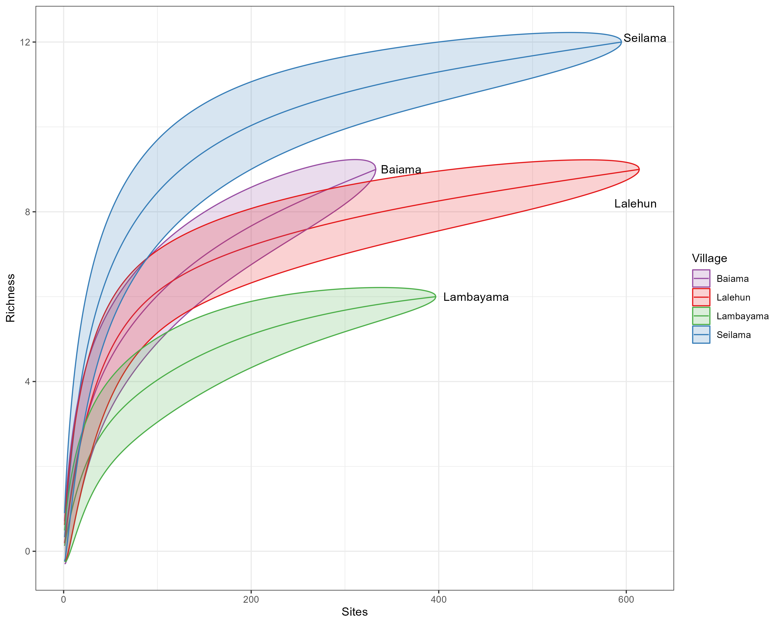

Supplementary material 5A. Species accumulation curves for each village site.

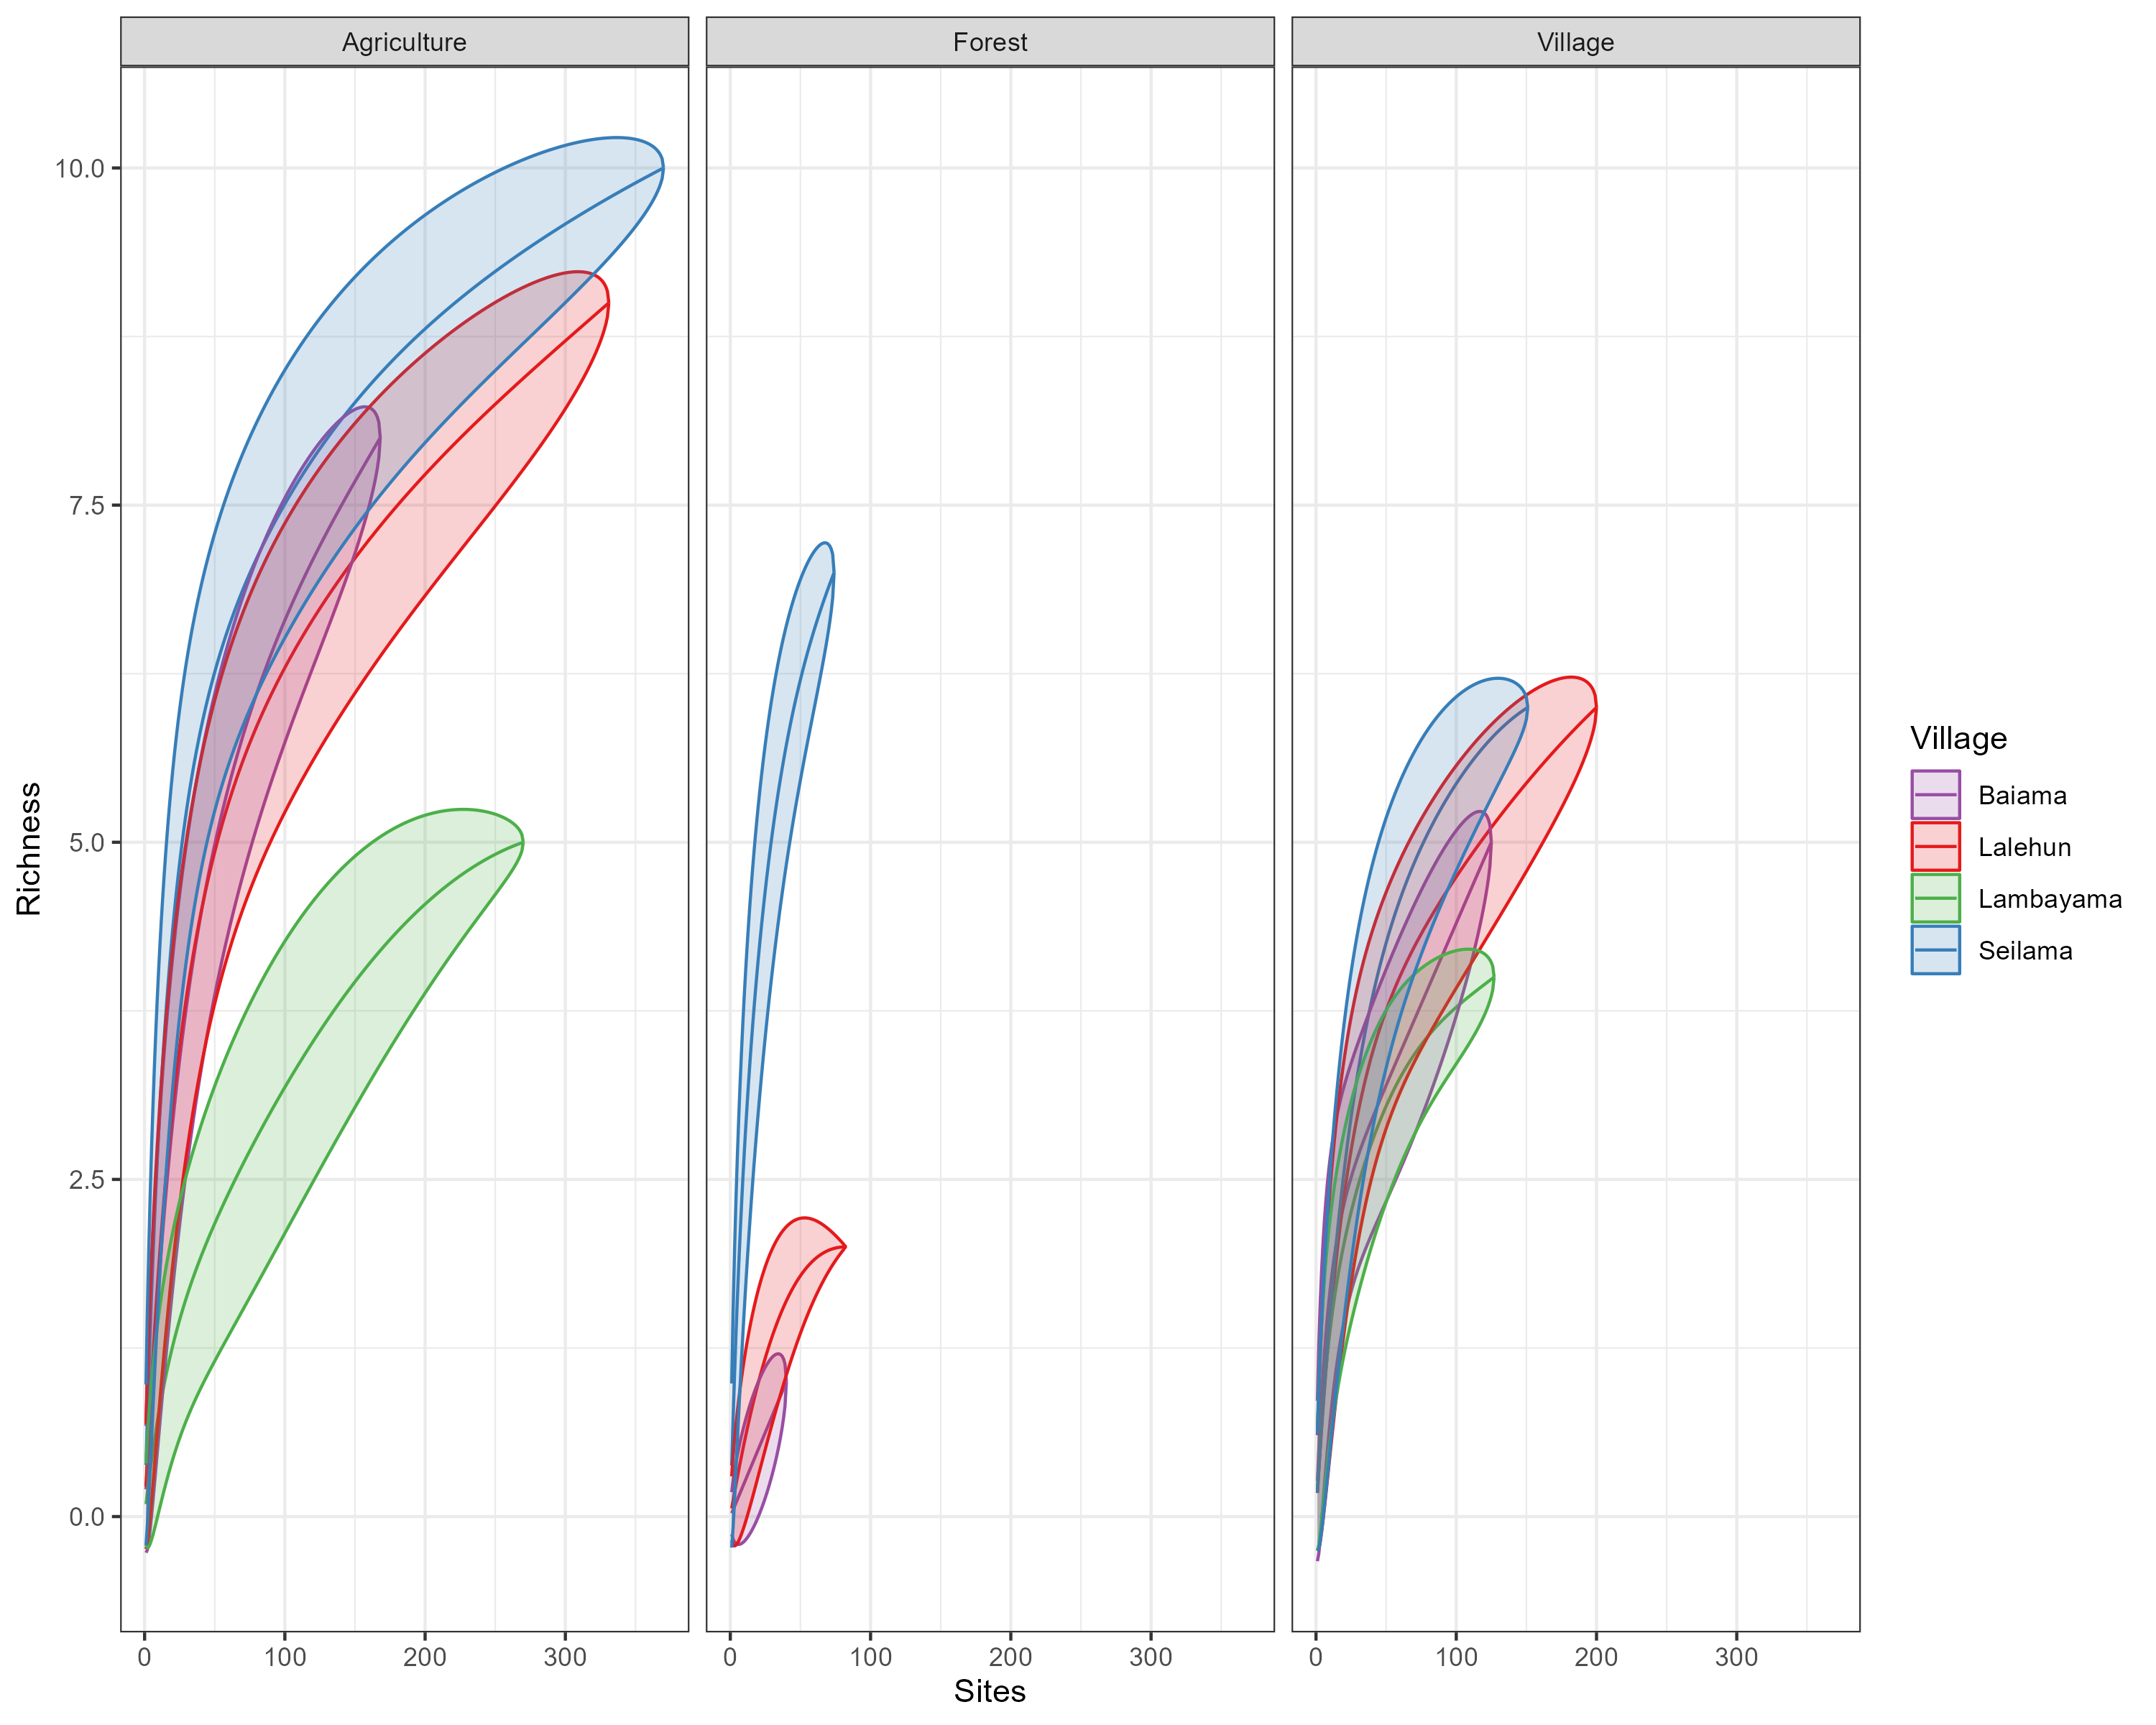

Supplementary material 5B. Species accumulation curves for each village site stratified by landuse type.

## Supplementary Material 6

## Supplementary Material 7

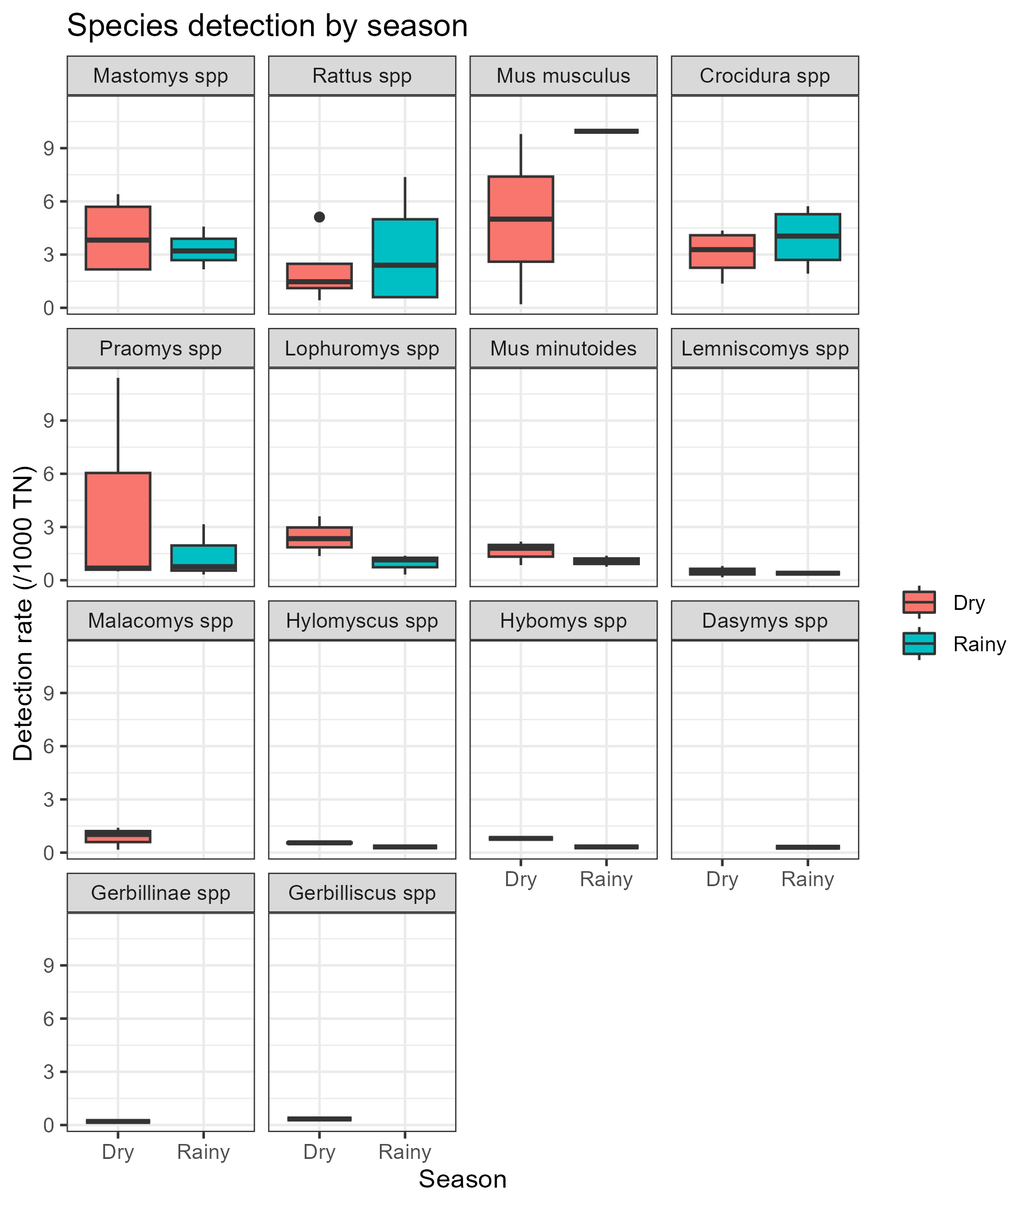

Supplementary material 7A. The detection rate for all species by season (Rainy = May-October, Dry = November-April) of trapping activity.

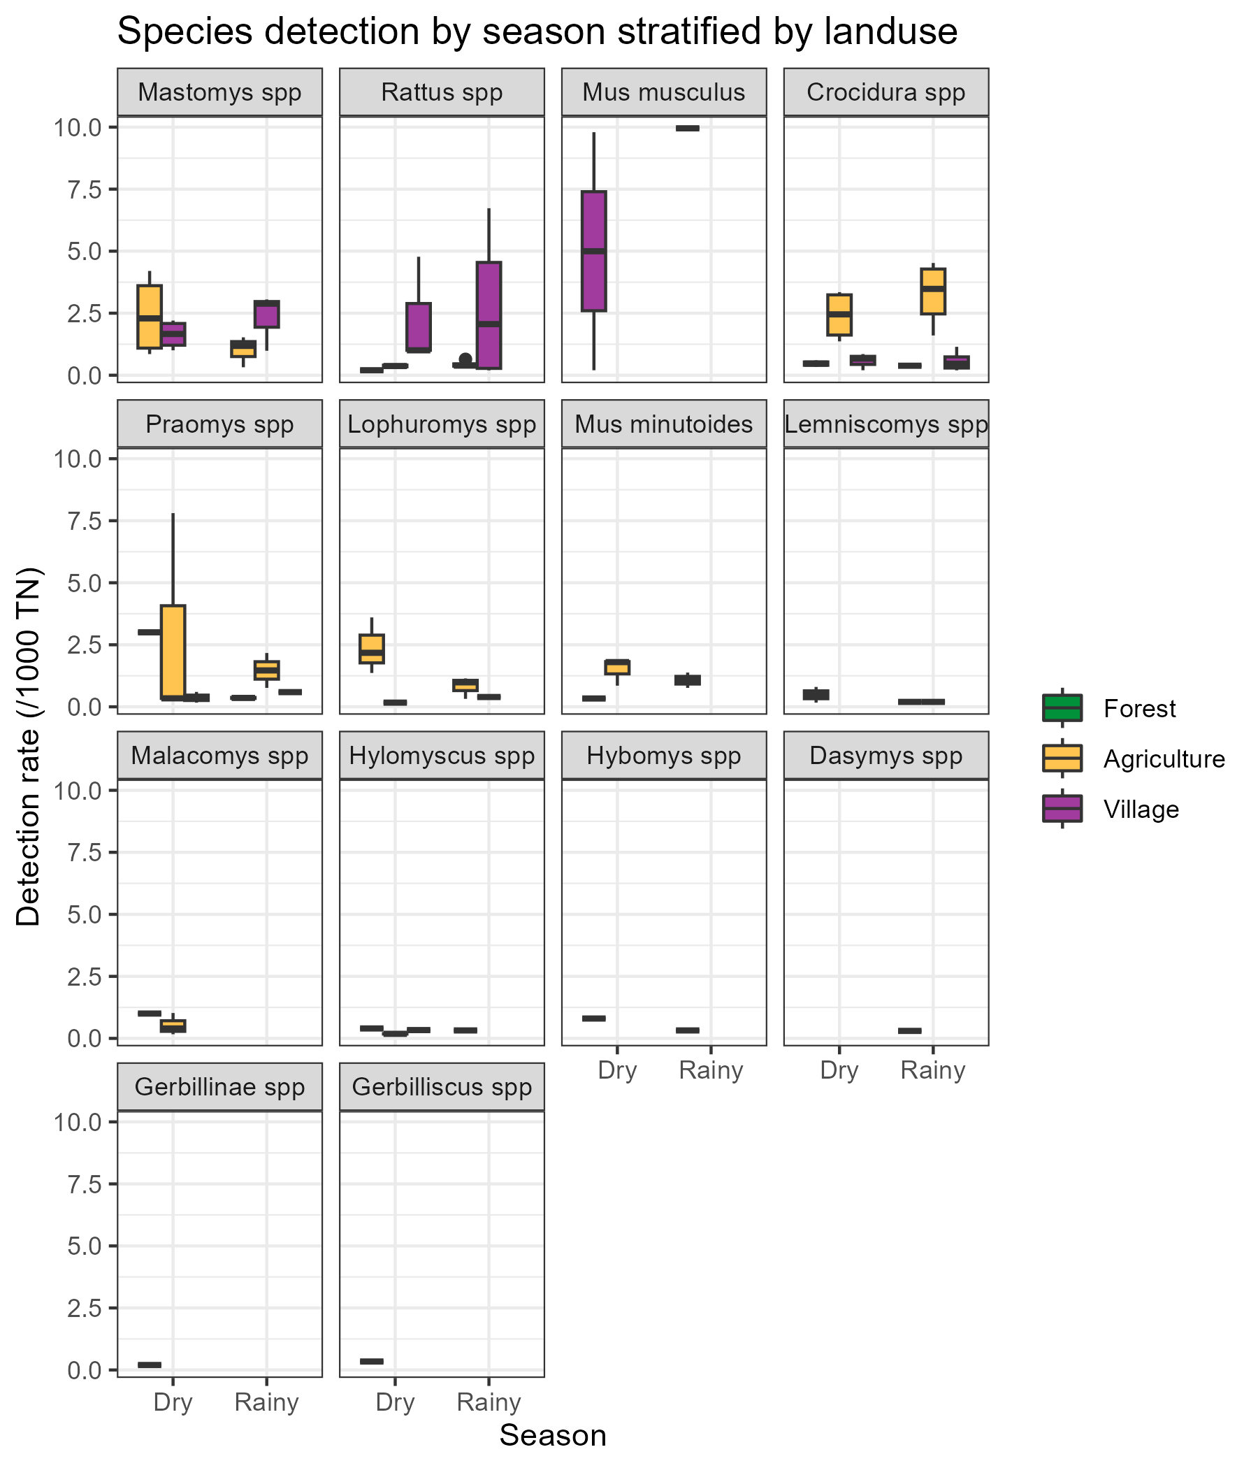

Supplementary material 7B. The detection rate for all species by season (Rainy = May-October, Dry = November-April) stratified by landuse type of trapping activity.

## Supplementary Material 9

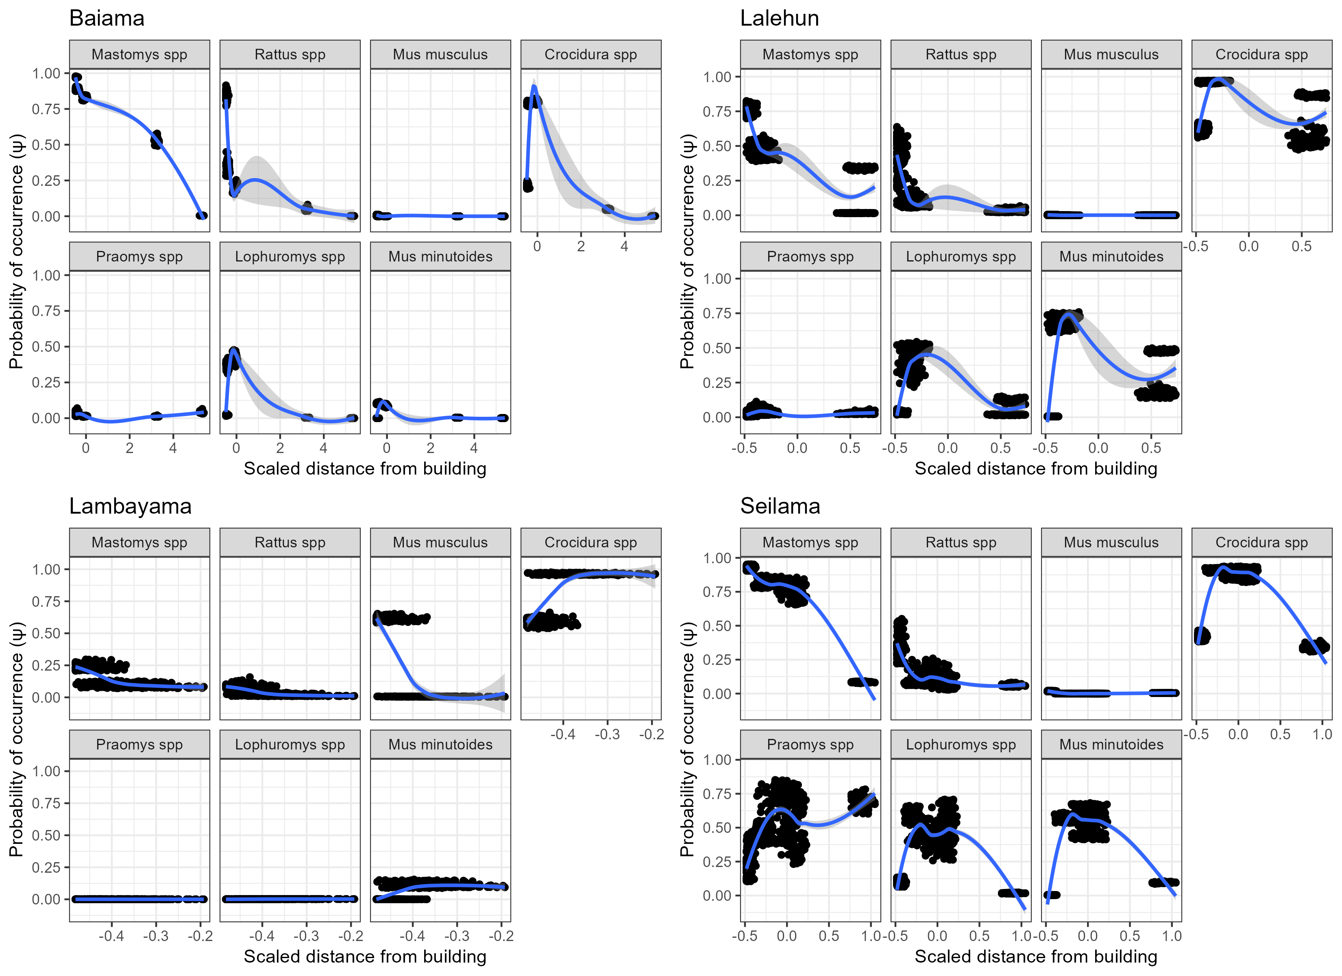

Supplementary material 9A: The marginal effect of scaled distance from building on the probability of occurrence of a species in a grid cell for each village study site. Generally a decline in probability of occurrence is observed with increasing distance. This decline is greatest for the commensal rodent species *M. natalensis*, *R. rattus* and *M. musculus*. *Praomys spp.*, *L. sikapusi* and *M. minutoides* display a more complex pattern where probability of occurrence increases over relatively short distances and then falls away as distances increase further. The trend line is a Locally estimated scatterplot smoothing (LOESS) model fit to the data with the formula (Scaled distance from building ~ Probability of occurrence).

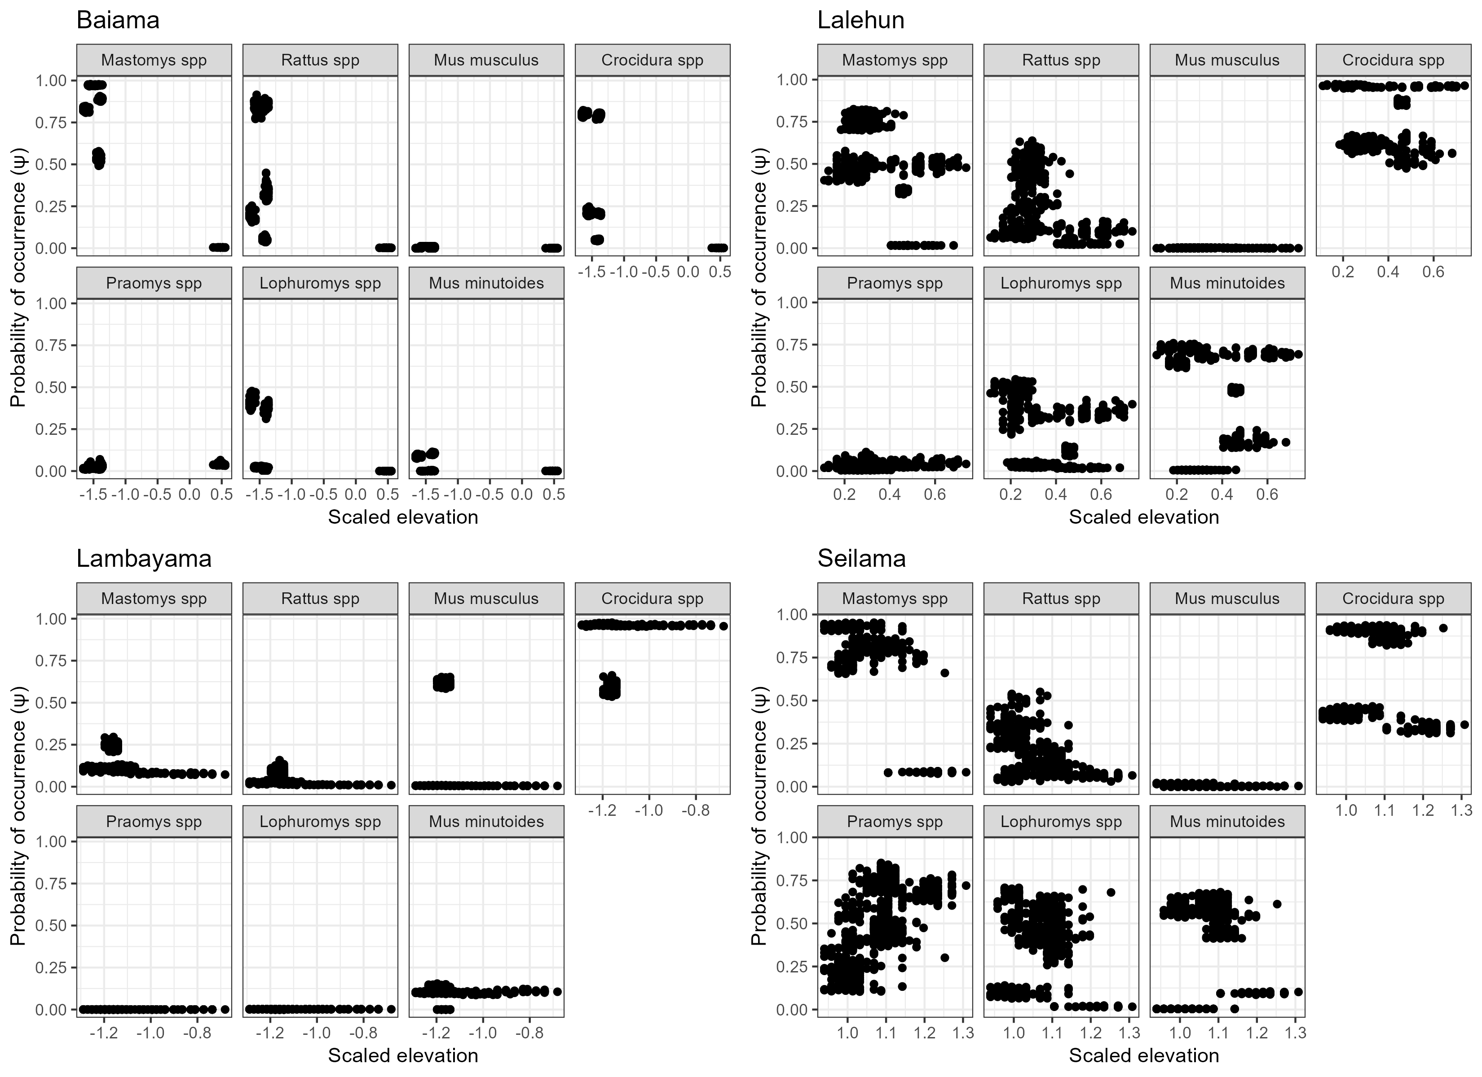

Supplementary material 9B: The marginal effect of scaled elevation on the probability of occurrence of a species in a grid cell for each village study site. No clear patterns are observed for individual species’, this may be due to the limited ranges of elevation sampled within and between grid cells.

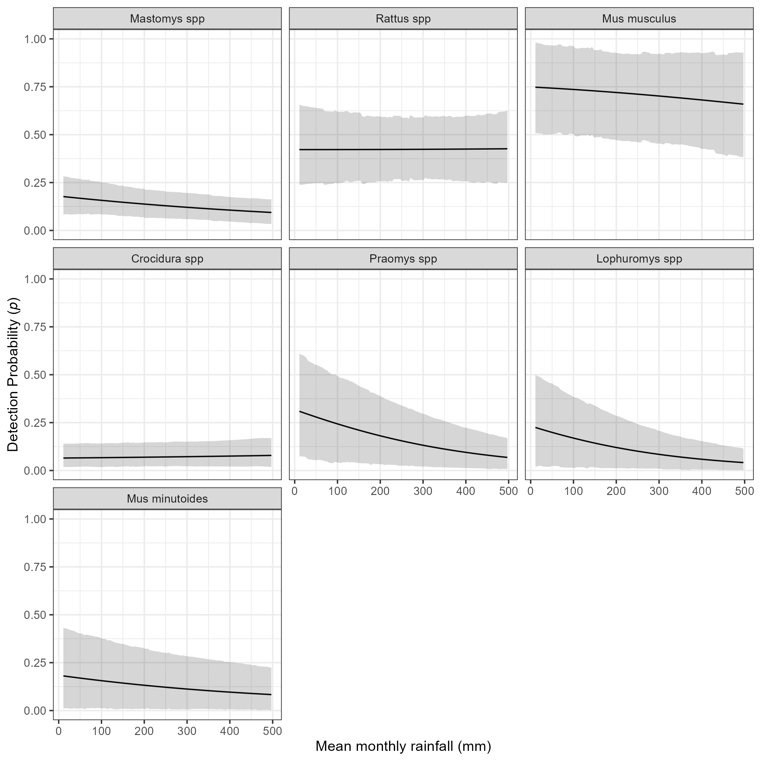

Supplementary material 9C: The marginal effect of mean monthly rainfall on the probability of detection of a species in a grid cell. The black line shows the mean modelled probability of detection for the amount of monthly rainfall, the shaded grey region represents the 95% Credible Interval (CrI). Probability of detection varies by species with higher values for the invasive rodent species *M. musculus* and *R. rattus*, than the native rodent species. There is a general response of decreasing probability of detection with increasing rainfall.

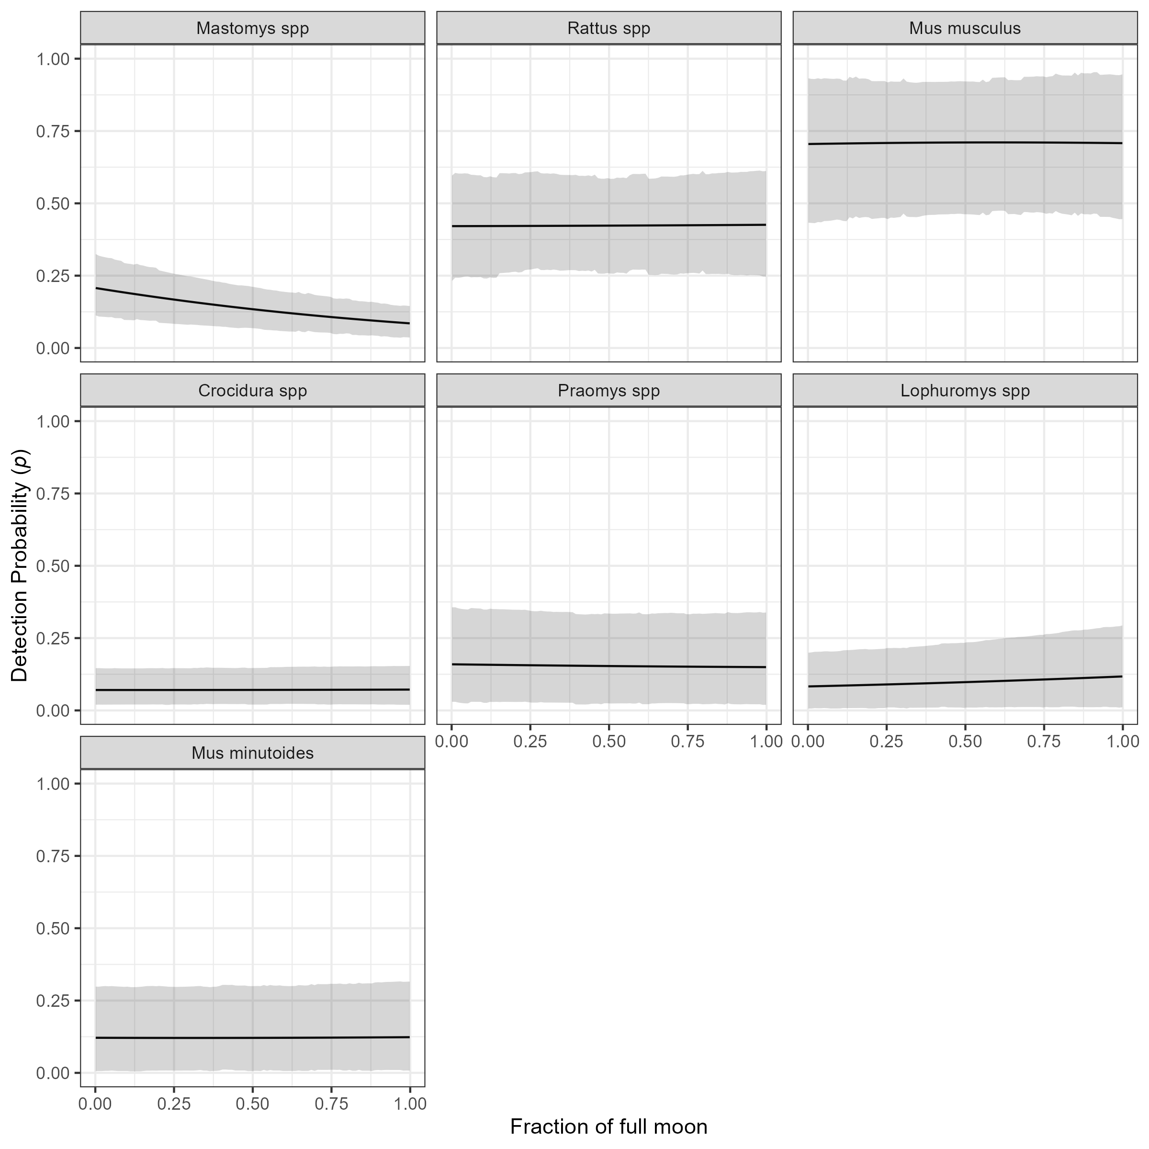

Supplementary material 9D: The marginal effect of the fraction of the full moon on the probability of detection of a species in a grid cell. The black line shows the mean modelled probability of detection for the moon phase, the shaded grey region represents the 95% CrI. Probability of detection varies by species with higher values for the invasive rodent species *M. musculus* and *R. rattus*, than the native rodent species. There is no important response to moon phase for most species. The probability of detection appears to fall for *M. natalensis* with increasing moon phase but the credible intervals overlap for the entire range.

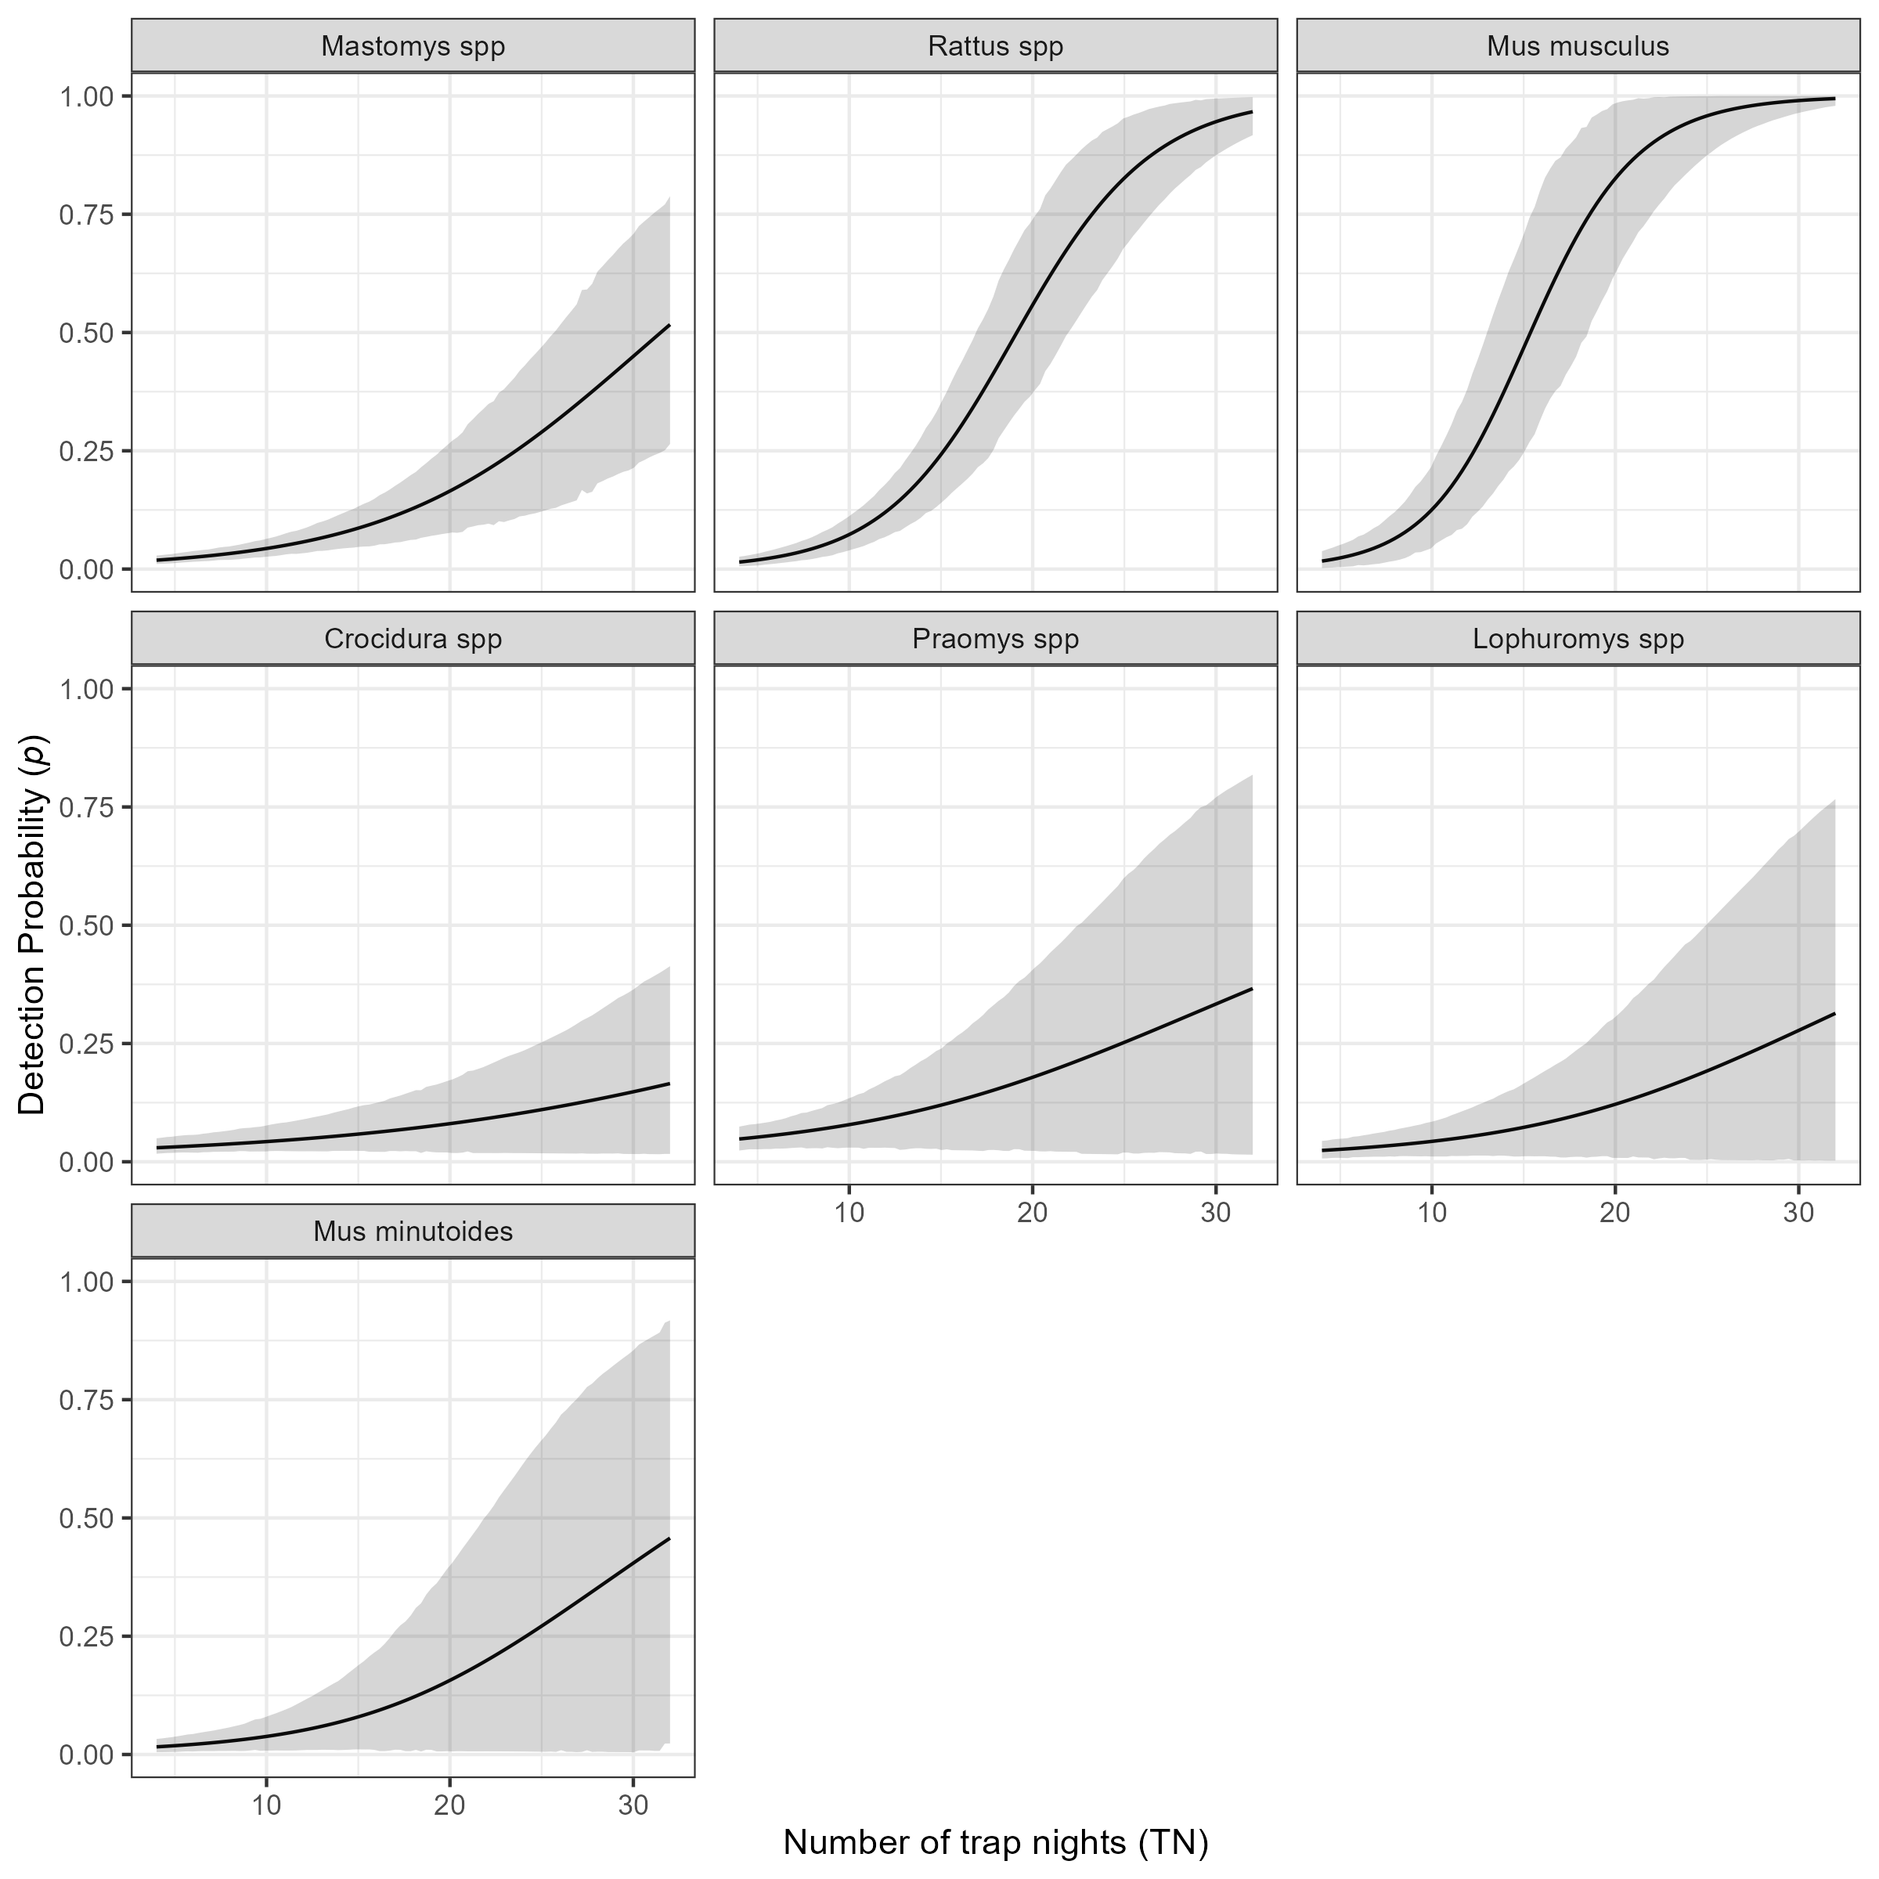

Supplementary material 9E: The marginal effect of trapping effort (TN) on the probability of detection of a species in a grid cell. The black line shows the mean modelled probability of detection trapping effort, the shaded grey region represents the 95% CrI. Probability of detection is low for all species at low levels of TN. The probability of detection with increasing TN varies by species. The invasive rodent species *M. musculus* and *R. rattus* show a sinusoidal response over the range of TNs that were observed in this study with the probability of detection being greater than 50% at relatively low numbers of TN (15 and 17 respectively). Much greater trapping effort were required to obtain the same probability of detection for the native rodent species. Only *M. natalensis* reached this threshold at 32 TN, with the other species requiring >32 TN to reach a probability of 50% detection.

# References

Altschul, S. F., W. Gish, W. Miller, E. W. Myers, and D. J. Lipman. 1990. “Basic Local Alignment Search Tool.” *Journal of Molecular Biology* 215 (3): 403–10. <https://doi.org/10.1016/S0022-2836(05)80360-2>.

Bangura, Umaru, Jacob Buanie, Joyce Lamin, Christopher Davis, Gedeon Ngiala Bongo, Michael Dawson, Rashid Ansumana, et al. 2021. “Lassa Virus Circulation in Small Mammal Populations in Bo District, Sierra Leone.” *BIOLOGY-BASEL* 10 (1). <https://doi.org/10.3390/biology10010028>.

Basinski, Andrew J., Elisabeth Fichet-Calvet, Anna R. Sjodin, Tanner J. Varrelman, Christopher H. Remien, Nathan C. Layman, Brian H. Bird, et al. 2021. “Bridging the Gap: Using Reservoir Ecology and Human Serosurveys to Estimate Lassa Virus Spillover in West Africa.” Edited by Amy Wesolowski. *PLOS Computational Biology* 17 (3): e1008811. <https://doi.org/10.1371/journal.pcbi.1008811>.

Benjamin, Daniel J., James O. Berger, Magnus Johannesson, Brian A. Nosek, E.-J. Wagenmakers, Richard Berk, Kenneth A. Bollen, et al. 2018. “Redefine Statistical Significance.” *Nature Human Behaviour* 2 (1): 6–10. <https://doi.org/10.1038/s41562-017-0189-z>.

Cuypers, Laura N, Wim L Cuypers, Amélie Gildemyn-Blomme, Laura Abraham, Senne Aertbeliën, Apia W Massawe, Benny Borremans, Sophie Gryseels, and Herwig Leirs. 2017. “No Evidence for Avoidance of Black Rat Scent by the Presumably Less Competitive Natal Multimammate Mouse in a Choice Experiment.” *African Zoology* 52 (2): 119–23. <https://doi.org/10.1080/15627020.2017.1307139>.

Doser, Jeffrey W., Andrew O. Finley, Marc Kéry, and Elise F. Zipkin. 2022. “spOccupancy: An r Package for Single-Species, Multi-Species, and Integrated Spatial Occupancy Models.” *Methods in Ecology and Evolution*. <https://doi.org/10.1111/2041-210X.13897>.

Fichet-Calvet, Elisabeth. 2014. “Chapter 5 - Lassa Fever: A Rodent-Human Interaction.” In *The Role of Animals in Emerging Viral Diseases*, edited by Nicholas Johnson, 89–123. Boston: Academic Press. <https://doi.org/10.1016/B978-0-12-405191-1.00005-3>.

Garba, Madougou, Ambroise Dalecky, Ibrahima Kadaoure, Mamadou Kane, Karmadine Hima, Sophie Veran, Sama Gagare, et al. 2014. “Spatial Segregation Between Invasive and Native Commensal Rodents in an Urban Environment: A Case Study in Niamey, Niger.” Edited by Jonas Waldenström. *PLoS ONE* 9 (11): e110666. <https://doi.org/10.1371/journal.pone.0110666>.

IUCN. 2016. “The IUCN Red List of Threatened Species 2016: Mastomys Natalensis.” International Union for Conservation of Nature. <https://doi.org/10.2305/IUCN.UK.2016-3.RLTS.T12868A22425266.en>.

Kingdon, Jonathan, and David Happold. 2013. “Mammals of Africa” 4.

Klitting, Raphaëlle, Liana E. Kafetzopoulou, Wim Thiery, Gytis Dudas, Sophie Gryseels, Anjali Kotamarthi, Bram Vrancken, et al. 2021. “Predicting the Evolution of Lassa Virus Endemic Area and Population at Risk over the Next Decades.” Preprint. Microbiology. <https://doi.org/10.1101/2021.09.22.461380>.

Leirs, Herwig, Ron Verhagen, and Walter Verheyen. 1993. “Productivity of Different Generations in a Population of Mastomys Natalensis Rats in Tanzania.” *Oikos* 68 (1): 53–60. <https://doi.org/10.2307/3545308>.

McCormick, J B, P A Webb, J W Krebs, K M Johnson, and E S Smith. 1987. “A Prospective Study of the Epidemiology and Ecology of Lassa Fever.” *The Journal of Infectious Diseases* 155 (3): 437–44. <https://doi.org/10.1093/infdis/155.3.437>.

Monadjem, Ara, Peter J. Taylor, Christiane Denys, and Fenton P. D. Cotterill. 2015. *Rodents of Sub-Saharan Africa: A Biogeographic and Taxonomic Synthesis*. Berlin, München, Boston: DE GRUYTER. <https://doi.org/10.1515/9783110301915>.

Pebesma, Edzer. 2018. “Simple Features for r: Standardized Support for Spatial Vector Data.” *The R Journal* 10 (1): 439–46. <https://journal.r-project.org/archive/2018/RJ-2018-009/index.html>.

QIAGEN. 2023. “DNeasy Blood & Tissue Kits.” January 20, 2023. <https://www.qiagen.com/us/products/discovery-and-translational-research/dna-rna-purification/dna-purification/genomic-dna/dneasy-blood-and-tissue-kit>.

R Core Team. 2021. *R: A Language and Environment for Statistical Computing*. Vienna, Austria: R Foundation for Statistical Computing. <https://www.R-project.org/>.

Redding, David W., Rory Gibb, Chioma C. Dan-Nwafor, Elsie A. Ilori, Rimamdeyati Usman Yashe, Saliu H. Oladele, Michael O. Amedu, et al. 2021. “Geographical Drivers and Climate-Linked Dynamics of Lassa Fever in Nigeria.” *Nature Communications* 12 (1): 5759. <https://doi.org/10.1038/s41467-021-25910-y>.

Redding, David W., Lina M. Moses, Andrew A. Cunningham, James Wood, and Kate E. Jones. 2016. “Environmental-Mechanistic Modelling of the Impact of Global Change on Human Zoonotic Disease Emergence: A Case Study of Lassa Fever.” *Methods in Ecology and Evolution* 7 (6): 646–55. <https://doi.org/10.1111/2041-210X.12549>.

Simons, David. 2022. “Lassa Fever Cases Suffer from Severe Underreporting Based on Reported Fatalities.” *International Health*, November, ihac076. <https://doi.org/10.1093/inthealth/ihac076>.

Simons, David, Lauren A. Attfield, Kate E. Jones, Deborah Watson-Jones, and Richard Kock. 2023. “Rodent Trapping Studies as an Overlooked Information Source for Understanding Endemic and Novel Zoonotic Spillover.” *PLOS Neglected Tropical Diseases* 17 (1): e0010772. <https://doi.org/10.1371/journal.pntd.0010772>.

Watanabe, Sumio. 2010. “Asymptotic Equivalence of Bayes Cross Validation and Widely Applicable Information Criterion in Singular Learning Theory.” *J. Mach. Learn. Res.* 11 (December): 3571–94. <https://doi.org/10.5555/1756006.1953045>.

World Health Organisation. 2022. “Lassa Fever.” 2022. <https://www.who.int/health-topics/lassa-fever#tab=tab_1>.